Container Crop Management Tools (http://www.bmptoolbox.org)

OUTLINE
I. Introduction
II. CCROP - the model
A. Input Files
1. Management input file (P_spec.txt)
2. Weather input file (WFNAME.wth)
3. Plant file (PFNAME.plt)
4. Irrigation file (IFNAME.irr) - Optional
5. Solution fertilizer input file (SFFNAME.sfn) - Optional
B. Driver and Subroutine Programs
1. Driver program
2. Water subroutine
3. Plant subroutine
4. Nutrient subroutine
5. Output subroutine
C. Processes and functions
1. Plant growth and development
a. DT function
b. Sink-limited growth
c. Conversion of leaf area growth to biomass growth
d. Source-limited growth
e. Actual growth – source vs. sink
2. Nitrogen demand, supply, uptake, sufficiency
a. Plant N demand
b. N supply
c. Plant N uptake
d. N sufficiency
3. Evaporation and water sufficiency
a. Potential evaporation
b. Actual evaporation
c. Water sufficiency
4. N release from controlled-release fertilizer
5. Supplemental fertilizer
a. Topdress fertilizer
b. Solution fertilizer
6. Water and N balance
a. Irrigation
b. Irrigation enhancement factor
c. Drainage and runoff
d. N leaching, runoff N
e. N balance
7. Pruning and plant size
a. Pruning
b. Size
8. Temperature functions
a. Unbiased temperature average (TMEAN)
b. Biased temperature average (TBMEAN)
c. Biased photosynthetically active radiation (PARB)
d. Biased temperature maximum (TMAXB)
e. Biased temperature (TBIAS)
D. Output files
1. Daily output
a. General
b. Plant
c. N release
d. Runoff
2. Summary output
a. Container basis
b. Area basis
III. CCROP-MT - management tools
A. GROWER TOOL
B. COMPARISON TOOLS
C. TECHNICAL TOOL
D. REAL-TIME IRRIGATION SCHEDULING TOOL

I. INTRODUCTION
Container Crop Management Tools (CCROP-MT) is a collection of web-based programs which serve as decision-making tools for container nursery management. The foundation of CCROP-MT is the plant growth model CCROP (Container Crop Resource Optimization Program) which simulates the growth and associated water and nutrient relationships of containerized ornamental plants. CCROP-MT serves as a web-based interface that allows the user to select inputs, execute CCROP simulations, and view output. This manual first describes CCROP and the processes it simulates. This is followed by a discussion of CCROP-MT and how it can be used as a decision-making tool.

II. CCROP – The Model
CCROP (Container Crop Resource Optimization Program) is a plant growth simulation model that was developed using FORTRAN programming language. CCROP consists of a driver program and four subroutines: water, plant, nutrient, and output (Fig. 1). The driver program reads input data, initializes variables, performs certain calculations, and controls the passing of variables between subroutines for daily rate and integration calculations, including output. Input data are read from management, weather and plant files and optionally from irrigation and supplemental solution fertilizer files. Output is written to text (.txt) files which contain either daily output data or summary output data.
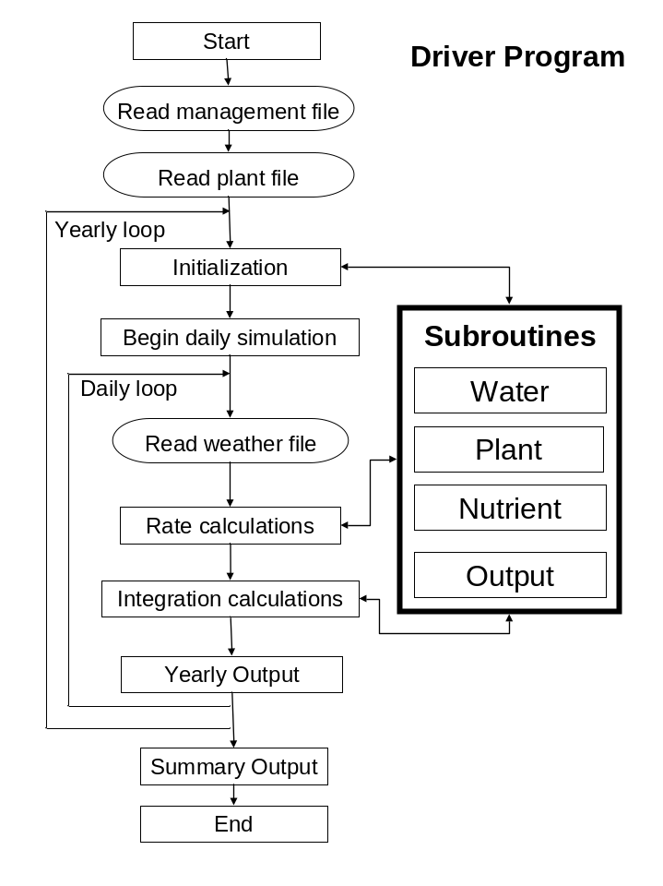

Fig. 1. Information flow in CCROP.

A. CCROP - Input Files
Input files allow the user to specify conditions under which the simulation will be run. Each input file must be formatted exactly with respect to headers and rows. Format spacing within rows is not important for management and plant input files as long as there is a space between parameter values; however, format spacing within rows is critical for weather, irrigation and solution fertilizer input files. See appendix for examples of all input files. *=run number.

1. Management file (*_P_SPEC.txt)
The user specifies cultural practices in the management file. Parameters include dates for planting, moving, irrigation, topdress fertilizer application, pruning, and finishing. In cases where scheduling of practices is not based on fixed dates, options for scheduling are provided by selecting criteria which trigger a schedule change. For example, containers can be moved when a critical leaf area index is reached, irrigation can be scheduled based upon the managed allowable deficit concept and crops can be finished when a marketable size is reached.
A list of input variables in the management file are given in Table 1 and described below [VARIABLE (type of variable)].

Integer = non-decimal values
Real = decimal values
Character = letter characters (case sensitive)

Note: enter -99 for any variable that is not applicable
*Planting detail
PLT_DOY (Integer)
Plant date in Julian Day - assumed to be Day 1 of simulation
START_YR (Integer)
First year to run simulation
END_YR (Integer)
Last year to run simulation (simulation may actually end on following year)
MOVE (Character)
Enter ‘FIXED’ or ‘LAI’ to indicate basis for moving containers
FIXED = move containers after fixed number of days after planting
LAI = move containers when critical LAI is reached
MOVE1 (Integer)
Days after planting for 1st move. This is only applicable if MOVE=’FIXED’.
Enter -99 if plants are never moved.
MOVE2 (Integer)
Days after planting for 2nd move. This is only applicable if MOVE=’FIXED’.
Enter -99 if plants are not moved.
MOVE3 (Integer)
Days after planting for 3rd move. This is only applicable if MOVE=’FIXED’.
Enter -99 if plants are not moved.
MOVE_LAI (Real)
Threshold leaf area index to trigger container move. This is only applicable if MOVE=’LAI’.
NOM (Integer)
Maximum number of moves for triggered move. This is only applicable if MOVE=’LAI’.

*Transplant detail
ILA (Real)
Initial leaf area of transplant (cm²)
HT_ORIG (Real)
Height of transplant from substrate surface to uppermost foliage (cm)
W_ORIG (Real)
Average canopy width of transplant (cm)
TW_Nact (Real)
Nitrogen concentration in shoot (aboveground) tissue (g N/g shoot)
RW_Nact (Real)
Nitrogen concentration in root tissue (g N/g root)

*Finish detail
FINISH (Character)
Enter ‘FIXED’ or ‘SIZE’ to indicate how to finish the crop
HARVDAYS (Integer)
Days after planting to finish crop. Only applicable if FINISH=’FIXED’.
HARV_HT (Real)
Height of plant when crop is finished (cm). Only applicable if FINISH=’SIZE’.

*Size adjustment detail
CHK_DAYx (Integer) (x= 1, 2, or 3)
Days after planting for size adjustment.
This is designed to calibrate model with actual field value for real-time simulations.
CHK_HTx (Real) (x= 1, 2, or 3)
On CHK_DAYX plant height is assigned this value (cm)
CHK_Wx (Real) (x= 1, 2, or 3)
On CHK_DAYx plant width is assigned this value (cm)

*Container detail
S_VOL (Real)
Substrate volume in container (cm³). This is the fill volume not container volume.
POTDIAM (Real)
Top diameter of container (cm)
PTA0 (Real)
Total production area allotted to each container at planting (cm²). This value is dependent upon plant spacing.
PTAx (Real) (x=1, 2, or 3)
Total area allotted to each container after 1st, 2nd, and 3rd moves (cm²)

*Substrate water specs
SWLL (Real)
Substrate water content at drained upper limit or container capacity (g water/g substrate). Container capacity condition is obtained by saturating the substrate in the container and allowing gravitational water (water not held by gravity) to drain from the container. Water content determined by oven-drying is reported on a volumetric basis (cm³ water/cm³ substrate)
SWDUL (Real)
Substrate water content at lower limit or permanent wilting point (-15 bar or -1.5 J/g). This condition can be met using a laboratory apparatus or can be estimated by sampling substrate in the root zone of a wilted plant. Water content determined by oven-drying is reported on a volumetric basis (cm³ water/cm³ substrate).

*Irrigation schedule
SCHED (Character)
Enter ‘FIXED’ if irrigation scheduling is based on fixed irrigation rates
Enter ’FILE’ if irrigation scheduling is based upon an input irrigation file
Enter ‘MAD’ if irrigation schedule is based upon recharging water lost through evapotranspiration and a managed allowable deficit.
RAINCUT (Character)
Enter ‘NO’ or ‘YES’ to indicate whether a rain cutoff sensor is used.
IRRx (Integer) (x=1, 2, or 3)
Days after planting to change irrigation rate. Only applicable if SCHED=’FIXED’.
MAD (Real)
Managed allowable deficit or the percent of available water that must be lost before irrigation is applied (%). Only applicable if SCHED=’MAD’.
IRR_NCONC (Real)
Nitrogen concentration of the irrigation water (ug/cm³). See *Supplemental solution fertilizer for inputting variable concentrations.

*Fixed irrigation rates
D_IRR0 (Real)
Daily fixed irrigation rate at planting (cm). Only applicable if SCHED=’FIXED’.
D_IRRx (Real) (x =1, 2, or 3)
Daily irrigation rate associated with each IRRx (cm). Only applicable if SCHED=’FIXED’.

*Input files
WFNAME (Character) (8 max characters)
Specifies filename of weather input file (weather filenames have .WTH extension).
PFNAME (Character) (8 max characters)
Specifies filename of plant input file (plant filenames have .WTH extension).
IFNAME (Character) (8 max characters)
Specifies filename of irrigation input file (weather filenames have .WTH extension).
Only applicable if SCHED = ’FILE’.
SFFNAME (Character) (8 max characters)
Specifies filename of solution fertilizer input file (weather filenames have .sfn extension).
Only applicable if SF = ’FILE’.

*Fertilizer detail
FERT (Real)
Fertilizer rate (g/container)
PCT_N (Real)
Percent total nitrogen of fertilizer (%)
PCT_CRN (Real)
Percent controlled-release nitrogen of fertilizer (%). PCT_CRN should be equal to or less than PCT_N.
FERT_DAYS (Integer)
Longevity rating of controlled-release nitrogen fertilizer (day). This is based upon the manufacturer’s rating which is typically the time it takes for 80-90% of controlled-release N to be released under laboratory conditions at constant temperatures, usually 21-25ºC.
APPL (Character)
Enter ‘INC’ if fertilizer is incorporated into the substrate at planting
Enter ‘SURF’ if fertilizer is surface-applied at planting

*Supplemental topdress fertilizer
TDF (Real)
Enter ‘FIXED’ for a fixed application day.
Enter ‘TRIG’ to trigger a supplemental fertilizer application when N release from fertilizer falls below a threshold value.
Enter ‘NONE’ or -99 if no supplemental topdress fertilizer is to be applied.
TD_DAYS (Integer)
Days after planting to apply supplemental topdress fertilizer. Only applicable if TDF=’FIXED’.
TD_TF (Real)
Threshold factor to trigger a supplemental topdress fertilizer application. If N release from controlled-release fertilizer falls below this threshold percent (%)of plant N demand then a supplemental topdress fertilizer application is automatically applied. Only applicable if TDF=’TRIG’.
FERT2 (Real)
Supplemental topdress fertilizer rate (g/container).
PCT_N2 (Real)
Percent total nitrogen of supplemental topdress fertilizer (%).
PCT_CRN2 (Real)
Percent controlled-release nitrogen of fertilizer (%) in supplemental topdress fertilizer. PCT_CRN2 should be equal to or less than PCT_N2.
FERT_DAYS2 (Integer)
Longevity rating of supplemental topdress controlled-release nitrogen fertilizer (day). This is based upon the manufacturer’s rating which is typically the time it takes for 80-90% of controlled-release N to be released under laboratory conditions at constant temperatures, usually 21-25ºC.

*Supplemental solution fertilizer detail
SF (Character)
Enter ‘FIXED’ for a fixed supplemental solution fertilizer application schedule.
Enter ‘TRIG’ to trigger a supplemental fertilizer application when N release from fertilizer falls below a threshold value.
Enter ‘FILE’ to input solution fertilizer schedule with a file.
Enter ‘NONE’ or -99 if no supplemental solution fertilizer is to be applied.
SF_START (Integer)
Days after planting to start solution fertilizer applications. Only applicable if SF=’FIXED’.
SF_END (Integer)
Days after plantin to end solution fertilizer applications. Only applicable if SF=’FIXED’.
SF_INT (Integer)
Interval between solution fertilizer applications (day).
SF_TF (Real)
Threshold factor to trigger solution fertilizer applications. If N release from controlled-release fertilizer falls below this threshold percent (%) of plant N demand, then supplemental solution fertilizer applications are made according to SF_INT and SF_NCONC until the crop is finished. Only applicable if SF=’TRIG’.
SF_NCONC (Real)
Solution fertilizer nitrogen concentration (ug/cm³)

*Pruning detail
PRUNE (Character)
Enter ‘FIXED’ for a fixed pruning schedule.
Enter ‘TRIG’ to trigger pruning at certain stage of development.
PR_DAYx (Integer) (x=1, 2, or 3)
Days after planting for 1st, 2nd, or 3rd pruning. Only applicable if PRUNE=’FIXED’.
PR_HTx (Real) (x=1, 2, or 3)
Height of canopy from substrate after 1st, 2nd, or 3rd pruning. Only applicable if PRUNE=’FIXED’.
PR_Wx (Real) (x=1, 2, or 3)
Width of canopy after 1st, 2nd, or 3rd pruning. Only applicable if PRUNE=’FIXED’.
PR_DT (Real)
Pruning is triggered when development days (DT) is equal to this value. Only applicable if PRUNE=’TRIG’.
PRHT_RED (Real)
Reduction in plant height for an automatically triggered pruning. Only applicable if PRUNE=’TRIG’.

Table 1. Management file input variables for CCROP. Capitalized words in Units column are text options for the corresponding input variable.

Parameter | Description | Units
PLT_DOY | planting day of year | Julian Day
START_YR, END_YR | first and last years to run simulation | year
MOVE | criterion for moving containers | FIXED or LAI
MOVE1, 2, 3 | days before 1st, 2nd, 3rd moves | days after planting
MOVE_LAI | Leaf area index to trigger move
NOM | maximum number of moves
ILA | initial leaf area | cm²
HT_ORIG, W_ORIG | Initial height and width | cm
TW_Nact and RW_Nact | initial N conc. in shoots and roots | g N/g tissue
FINISH | criterion for terminating season | FIXED or SIZE
HARVDAYS | finish after this number of days | days after planting
HARV_HT | finish when this height is reached | cm
S_VOL | volume of substrate in container | cm³
POT_DIAM | top diameter of container | cm
PTA0, 1, 2, 3 | area allotted containers at start and after 1st, 2nd, and 3rd moves | cm²
SWLL | substrate water content at lower limit | cm³/cm³
SWDUL | substrate water content at drained upper limit | cm³/cm³
SCHED | irrigation schedule | FIXED, MAD, or FILE
RAINCUT | automatic rain cutoff | YES or NO
IRR1, 23 | days before 1st, 2nd, 3rd changes in irrigation | days after planting
MAD | substrate water deficit to trigger irrigation | % of available water
IRR_NCONC | N concentration of irrigation water | ug/cm³
D_IRR0, D_IRRx | initial irrigation rate, rate after x change | cm/day
WFNAME | weather file name
PFNAME | plant species file name
IFNAME | irrigation file name (optional)
SFFNAME | solution fertilizer file name (optional)
FERT | fertilizer N rate | g/container
PCT_N | total N content of fertilizer | %
PCT_CRN | controlled-release N content of fertilizer | %
CRF_DAYS | longevity rating of fertilizer | day
APPL | fertilizer application method | INC or SURF
TDF | topdress fertilizer application schedule | FIXED,TRIG,NONE
TD_DAY | day to apply topdress fertilizer | days after planting
TD_TF | topdress fertilizer application threshold factor | N release/N uptake
FERT2, PCT_N2, PCT_CRN2, CRF_DAYS2 | topdress fertilizer specs (see above)
SF | solution fertilization schedule | FIXED, TRIG, or FILE, NONE
SF_START, SF_END | day to start and stop solution fertilization | days after planting
SF_INT | time interval between solution fertilizer applications | day
SF_TF | threshold factor for triggering solution fertilizer applications (N release as percent of N demand) | %
SF_NCONC | solution fertilizer N conc. | ug/cm³
PRUNE | prune schedule | FIXED, TRIG, NONE
PR_DAY1,2,3 | days to prune | days after planting
PR_HT1,2,3 | prune height | cm
PR_W1,2,3 | prune width | cm
PR_DT | development days (DT) to trigger prune
PRHT_RED | fractional reduction in shoot height

2. Weather input file (WFNAME.wth)
A CPM weather file is a text file which includes a heading followed by daily weather observations. The heading contains the altitude of the weather station which is used in evapotranspiration calculations. The input weather variables in the weather file are given in Table 4. Multiple years of weather data may be included in the weather file. Because solar radiation data is typically lacking in most historical weather data sets, a reasonable estimate can be made using the weather generator program WGENR (Grant, 2004; Fraisse, 2006). For real-time use of CPM, the weather file must be updated daily.

Table 4. Daily input variables in weather files read by CPM.

Input variable | Description | Units
YEAR | Year
DOY | Day of year
SRAD | Daily solar radiation | MJ
TMAX | Daily maximum temperature | ºC
TMIN | Daily minimum temperature | ºC
RAIN | Daily rainfall | mm

3. Plant input file (PFNAME.plt)
The plant input file contains parameter values specific to the plant species being grown. The plant filename for Viburnum odoratissimum is VIBUR_OD.PLT which would be designated in the management file if this crop were grown. A list of the parameters in the plant input file is given in Table 2 and described below.

*Crop parameters
CROPEC (Real)
Coefficient used in calculating the aerodynamic component for plant evaporation.
See p.**
Water subroutine:
AEROCOMP =(GAMMA/(DELTA+GAMMA)*CROPEC*VPD**1.5)/LATHEAT
EPO =(RADCOM+AEROCOMP)*(1.-EXP(-0.92*LAI))
IF_MAX(Real)
Maximum value in logistics equation relating leaf area to irrigation enhancement factor.
See p.**.
Driver program:
IRR_EF=IF_MAX-(IF_MAX-1)/(1+(LA/(IF_INFL*POT_TOPAREA))**4)
IF_INFL (Real)
Used to relate top area of container to inflection point for logistics equation relating leaf area to irrigation enhancement factor.
See p.**.
Driver program:
IRR_EF=IF_MAX-(IF_MAX-1)/(1+(LA/(IF_INFL*POT_TOPAREA))**4)
KINPUT (Real)
Factor used to bias temperature due to solar radiation effect. Biased temperature is subsequently used in photosynthesis and development functions.
See p.**.
Driver program:
BRAD=SOLAR*DRF*exp(-0.7*LAI)*(1-POT_TOPAREA/PTA)
TMAXB=TMAX+KINPUT*BRAD
TDMIN, TDOPTMIN, TDOPTMAX and TDMAX (Real)
These four values define lower limit (TDMIN), upper limit (TDMAX) and optimum (TDOPTMIN and TDOPTMAX) temperatures for determining potential rate of plant development.
Driver program:
DTSLOPEMIN=1/(TDOPTMIN-TDMIN)
DTSLOPEMAX=1/(TDMAX-TDOPTMAX)
RDTN1=min(DTSLOPEMIN*(TMAXB-TDMIN),1.)
RDTN2=min(DTSLOPEMIN*(TMIN-TDMIN),1.)
RDTX1=min(-DTSLOPEMAX*(TMAXB-TDMAX),1.)
RDTX2=min(-DTSLOPEMAX*(TMIN-TDMAX),1.)
RDT=max(min((RDTN1+RDTN2)*0.5,(RDTX1+RDTX2)*0.5),0.01)
*Leaf growth parameters
RTPF (Real)
Root partitioning factor for portioning growth between shoots and roots.
See p.**.
Plant subroutine:
IF(d_PWSI.ge.d_PWSO) THEN
d_TW=d_PWSO*(1-RTPF) !source-limited shoot growth
d_RW=d_PWSO*RTPF !source-limited root growth
IF(d_PWSI.eq.0) THEN
d_LA=0
ELSE
d_LA=d_LA*(d_PWSO/d_PWSI)
ENDIF
ELSE
d_TW=d_PWSI*(1-RTPF) !sink-limited top growth
d_RW=d_PWSI*RTPF+0.4*(d_PWSO-d_TW) !portion of extra source to root ENDIF
LGC1, LGC2 (Real)
Leaf growth coefficients used to relate substrate volume to leaf area maximum which is used in logistics equation to describe sink-limited growth.
See p.**.
Plant subroutine:
LAMAX=LGC1*S_VOL**LGC2 !for logistics growth when DT<DTFL
LGC3, LGC4 (Real)
Leaf growth coefficients used to relate substrate volume to leaf area growth rate during linear phase (DT>DTFL) of sink-limited growth.
See p.**.
Plant subroutine:
IF(DT.lt.DTFL)THEN
LASI=LAMAX-(LAMAX-ILA)/(1+(DT/DTFL)**3)
d_LA=(LASI-LASIY)*min(NSUF,WSUF)
LASIY=LASI
ELSE
d_LA=LGC3*S_VOL**LGC4*RDT*min(NSUF,WSUF)
ENDIF
LGC5 (Real)
Set to DTFL which is the inflection point of logistics equation relating DT to leaf area growth for non-linear phase of sink-limited growth. DTFL is also the DT which defines the beginning of linear growth phase of sink-limited growth.
See p.**.
Plant subroutine:
IF(DT.lt.DTFL)THEN
LASI=LAMAX-(LAMAX-ILA)/(1+(DT/DTFL)**3)
d_LA=(LASI-LASIY)*min(NSUF,WSUF)
LASIY=LASI
ELSE
d_LA=LGC3*S_VOL**LGC4*RDT*min(NSUF,WSUF)
ENDIF
LGC6 (Real)
Coefficient used to bias clear day radiation effect when determining biased solar radiation for source limited growth.
See p.**.
Driver program:
PARB=min(SOLAR*0.5,CDR*0.5*LGC6)
d_PWSO=RUE*PARB*TEMFACSO*(1-exp(-CINT*LAI))*min(WSUF,NSUF)*0.0001*PTA !source-limited growth (g/plant)
LGC7, LGC8 (Real)
Leaf growth coefficients relating LA growth to shoot biomass growth
See p.**.
Plant subroutine:
IF(LAI.lt.2.5)THEN
d_PWSI=LGC7*d_LA
ELSE
d_PWSI=(LGC7+(LAI-2.5)*LGC8)*d_LA
ENDIF
RUE (Real)
Factor related to the efficiency of converting captured solar radiation to plant biomass in source limited growth equation.
See p.**.
Plant subroutine:
d_PWSO=RUE*PARB*TEMFACSO*(1-exp(-CINT*LAI))*min(WSUF,NSUF)*0.0001*PTA !source-limited growth (g/plant)
CINT (Real)
Extinction coefficient used to describe the relationship between leaf area index and light capture by the plant canopy.
See p.**.
Plant subroutine:
PARB=min(SOLAR*0.5,CDR*0.5*LGC6)
d_PWSO=RUE*PARB*TEMFACSO*(1-exp(-CINT*LAI))*min(WSUF,NSUF)*0.0001*PTA !source-limited growth (g/plant)

*Nitrogen supply parameters
NSUP_MAX1, NUPMAX2 (Real)
Parameters relating substrate volume to maximum N supply for N supply function.
See p.**.
Plant subroutine:
NSUPPLY=NSUP_MAX1*S_VOL**NSUP_MAX2*(1-exp(-NSUP_RF*RW))*
(1-1/(1.+(SUB_NCONC/NSUP_C1)**NSUP_C2))
NSUP_RF (Real)
Factor relating N supply to root biomass.
See p.**.
Plant subroutine:
NSUPPLY=NSUP_MAX1*S_VOL**NSUP_MAX2*(1-exp(-NSUP_RF*RW))*
(1-1/(1.+(SUB_NCONC/NSUP_C1)**NSUP_C2))
NSUP_C1, NUPC2 (Real)
Parameters relating substrate volume to maximum N supply for N supply function.
See p.**.
Plant subroutine:
NSUPPLY=NSUP_MAX1*S_VOL**NSUP_MAX2*(1-exp(-NSUP_RF*RW))*
(1-1/(1.+(SUB_NCONC/NSUP_C1)**NSUP_C2))
NSUF_C1, NSUF_C2 (Real)
Parameters relating relative N deficiency in shoots to N sufficiency.
See p.**.
Plant subroutine:
TRELN=(TW_Nact-TW_Nmin)/(TW_Nopt-TW_Nmin) !relative N deficiency factor
IF(TRELN.LT.NSUF_TF) THEN
NSUF=NSUF_C1*TRELN**NSUF_C2
ELSE
NSUF=1.
NSUF_TF (Real)
Threshold fraction for relating relative N deficiency in shoots to N sufficiency.
See p.**.
Plant subroutine:
TRELN=(TW_Nact-TW_Nmin)/(TW_Nopt-TW_Nmin) !relative N deficiency factor
IF(TRELN.LT.NSUF_TF) THEN
NSUF=NSUF_C1*TRELN**NSUF_C2
ELSE
NSUF=1.

*Nitrogen concentration parameters
TW_Noptmax, TW_Noptmin, DT_Nmax, DT_Nmin (Real)
Parameters describing the two slopes (SLOPEN1 and SLOPEN2) used to calculate optimum N concentrations in shoot biomass depending upon development time (DT). DT_Nmin is noteworthy since it is the DT when optimal shoot N reaches a maximum.
See p.**.
Plant subroutine:
SLOPEN1=(TW_Noptmax-TW_Noptmin)/DT_Nmin
SLOPEN2=(TW_Noptmax-TW_Noptmin)/(DT_Nmax-DT_Nmin)**2
IF(DT.LE.DT_Nmin) THEN
TW_Nopt=TW_Noptmin+slopeN1*DT
ELSE
TW_Nopt=TW_Noptmin+slopeN2*(DT-DT_Nmax)**2
ENDIF
RW_Noptdiff (Real)
This constant is subtracted from optimal shoot N concentration to determine optimal root N concentration.
See p.**.
Plant subroutine:
RW_Nopt=TW_Nopt-RW_Noptdiff
TW_Nmin (Real)
This constant is the minimum N concentration in shoots.
See p.**.
Plant subroutine:
TRELN=(TW_Nact-TW_Nmin)/(TW_Nopt-TW_Nmin) !relative N deficiency factor
*Size parameters
WDC1,WDC2,WDC3,WDC4,HTC1,HTC2,HTC31,HTC32 (Real)
Parameters relating changes in LA to changes in plant height and width.
See p.**.
Plant subroutine:
IF(LA.lt.200)THEN
WIDTH=WIDTH+WDC1*d_LA
HT=HT+HTC1*d_LA
ELSEIF(LA.lt.1025)THEN
WIDTH=WIDTH+WDC2*d_LA
HT=HT+HTC2*d_LA
ELSEIF(LA.lt.3725)THEN
WIDTH=WIDTH+WDC3*d_LA
IF(POTDIAM.gt.18)THEN
HT=HT+HTC32*d_LA
ELSE
HT=HT+HTC31*d_LA
ENDIF
ELSEIF(LA.gt.3725)THEN
WIDTH=WIDTH+WDC4*d_LA
HT=HT+HTC32*d_LA
ENDIF

*Photosynthesis temperature factors
Phototemp1, Phototemp2, Phototemp3 (Real)
Coefficients used in the calculation of temperature factor affecting photosynthesis in source-limited growth functions.
See p.**.
Plant subroutine:
TEMFACSO=PHOTOTEMP1-PHOTOTEMP2*(TBIAS-PHOTOTEMP3)**2
!temp factor for modifying source calculations
TEMFACSO=MIN(TEMFACSO,1.0)
TEMFACSO=MAX(TEMFACSO,0.0)
d_PWSO=RUE*PARB*TEMFACSO*(1-exp(-CINT*LAI))*min(WSUF,NSUF)*0.0001*PTA !source-limited growth (g/plant)

*Pruning factors
PRTWFAC, PRLAFAC (Real)
Factors relating prune height reduction to reduction in shoot biomass and leaf area.
See p.**.
Plant subroutine:
` TW=TW*(1-PRHT_RED*PRTWFAC) !new TW
LA=LA*(1-PRHT_RED*PRLAFAC) !new LA
Table 2. Parameters in the plant input file.

Input variable | Description | Units
CROPEC | crop evaporative coefficient | MJ/kPa
IF_MAX | irrigation enhancement factor maximum
IF_INFL | relates container top area to inflection point for logistic function estimating irrigation enhancement factor from leaf area
KINPUT | factor for biasing temperature due to solar radiation effect
TDMIN, TDOPTMIN, TDOPTMAX, TDMAX | Temperatures used in functions describing the influence of temperature on development | ºC
RTPF | root partitioning factor | g root/g total
LGC1,LGC2 | leaf growth coefficients for determining leaf area maximum
LGC3,LGC4 | leaf growth coefficients relating substrate volume to leaf area growth rate
LGC5 | Inflection point of logistics equation relating development time to leaf area growth
LGC6 | Coefficient used to bias clear day radiation effect for biased solar radiation
LGC7,LGC8 | Leaf growth coefficients relating LA growth to shoot biomass growth
RUE | radiation use efficiency | g/MJ
CINT | light extinction coefficient
NSUP_MAX1, NSUP_MAX2 | coefficients used to substrate volume to N supply maximum | g
NSUP_RF | root factor used to relate N supply to root growth
NSUP_C1, NSUP_C2 | parameters relating substrate N conc. to N supply
NSUF_C1, NSUF_C2 | factors for relating relative N conc in shoots to N sufficiency
NSUF_TF | threshold factor for relating relative N conc in shoots to N sufficiency
TW_Noptmax, TW_Noptmin; DT_Nmax, DT_Nmin | Parameters describing the two slopes (SLOPEN1 and SLOPEN2) used to calculate optimum N concentrations in shoot biomass depending upon development time (DT). DT_Nmin is noteworthy since it is the DT when optimal shoot N reaches a maximum. | g N/g shoot biomass; DT
RW_Noptdiff | constant difference between optimum N conc. in shoot and root tissues | g N/g tissue
TW_Nmin | minimum N conc. in shoot tissue | g N/g tissue
WDC1, WDC2, WDC3, WDC4 | factors for relating changes in leaf area with changes in plant width
HTC1, HTC2, HTC31, HTC32 | factors for relating changes in leaf area with changes in plant height
PHOTOTEMP1, PHOTOTEMP2, PHOTOTEMP3 | factors for biasing temperature effect on photosynthesis in source growth function
PRTWFAC | pruning shoot factor that relates reduction in height to reduction in shoot biomass
PRLAFAC | pruning shoot factor that relates reduction in height to reduction in leaf area

4. Irrigation input file (IFNAME.irr) - Optional
Users may input daily irrigation rates via an irrigation input file. The DATE for the first line of data under heading must correspond to the plant day-of-year (PLT_DOY) of the simulation using the irrigation file. There are only two variable in the irrigation input file (Table 3).

Table 3. Parameters in the irrigation input file (IFNAME.irr).

Input variable | Description | Units
DATE | date | YEARDOY
IRRIG | daily irrigation rate | cm

5. Solution fertilizer input file (SFFNAME.sfn) - Optional
This input file allows the user to input a daily record of solution fertilizer applications. The DATE for the first line of data under heading must correspond to the plant date (PLT_DOY). There are only two variables in the irrigation input file (Table 4).

Table 3. Parameters in the solution fertilizer input file.

Input variable | Description | Units
DATE | date | YEARDOY
SF_NCONC | solution fertilizer N concentration | g/cm³

B. CCROP - Driver and Subroutine Programs

This section is designed to give an overview of the driver and subroutine programs and the processes they simulate. Details of the individual processes are given in Section D.

1. Driver program (driver.for)
The driver program controls the simulation. The simulation is based upon a daily timeframe which means that input weather data and simulated processes (e.g. photosynthesis, evaporations, etc.) are all based upon daily averages. A general description of how the driver program controls the flow of information between subroutines in CCROP is given in Fig. 1 and in the following descriptions.

Initialization:
• Read management and plant input files
• Initialize parameters and set initial values
• Calculate area relationships
• Set substrate water content to container capacity

Begin daily simulation:
• Read in weather data
• Calculate PARB (biased solar radiation for photosynthesis function)
• Calculate bias temperatures for development and photosynthesis functions
• Calculate relative development time (RDT)
• Start daily simulation when start criteria are met
• Move containers, reset irrigation rates, prune or apply supplemental fertilizer if criteria are met
• Call variables from subroutine RATE calculations.
Note: Rate calculations do not rely on updated values from other subroutines
• Calculate irrigation and rain interception factors
• Call variables from subroutine INTEGRATION calculations
Note: Integration calculations rely on updated values from other subroutines
• Calculate available substrate N based upon N loss in drainage, plant N uptake, N release from CRF, and N in irrigation water
• Call output from output subroutine
• End daily simulation loop
• End crop simulation when harvest criteria are met
• Re-initialize parameters for next year’s run (yearly loop)
• Output summary data after final year
• End simulation

2. Water Subroutine
Initialization:
• Initialize parameters and set to initial values
• Calculate available water content

Rate calculations:
• Calculate potential plant and substrate evaporation

Integration calculations:
• Calculate irrigation to be applied
• Calculate irrigation and rain entering container
• Calculate amount of un-intercepted rain and irrigation contribute to runoff
• Determine actual substrate evaporation (ES)
• Calculate water sufficiency factor (WSUF)
• Determine actual plant evaporation (EP)
• Calculate evapotranspiration (ET)
• Adjust ET if insufficient water
• Calculate new substrate water content (SW)
• Calculate drainage from container
• Calculate runoff (un-intercepted plus drainage)
• Determine actual plant evaporation (EP)
• Calculate water related parameters on area basis and container basis
• Calculate running totals on area basis and container basis

3. Plant subroutine (plant.for)
Initialization:
• Initialize parameters and set to initial values
• Calculate shoot and root biomass based on initial leaf area
• Calculate slope constants for temperature effects on development time (DT)
• Calculate leaf area max and inflection point for sink-limited growth functions

Rate calculations:
• Adjust plant size if scheduled
• Prune plant if scheduled and adjust size, leaf area, and biomass

Integration calculations:
• Calculate optimum N concentration in plant tissues
• Determine N sufficiency in shoot tissue
• Calculate sink-limited growth potential
• Calculate source-limited growth potential
• Calculate actual growth based upon whether growth is sink-limited or source-limited
• Calculate N supply in substrate based upon substrate N conc. and root biomass
• Calculate N demand based upon biomass growth and optimal tissue N concentration
• Calculate plant N uptake based upon whether N supply meets N demand
• Calculate prune delay
• Update biomass, N concentration, leaf area and size

4. Nutrient subroutine (nutrient.for)
Initialization:
• Initialize parameters and set to initial values
• Calculate N applied with fertilizer

Rate calculations:
• Calculate parameters for N release functions
• Start topdress fertilizer application if scheduled
• Start solution fertilizer application if scheduled
• Determine N release for initial and any supplemental CRF applications

Integration calculations:
• Calculate N in drainage, un-intercepted water and runoff
• Update running totals on container basis and area basis
• Determine need for supplemental topdress or solution fertilizer if scheduled

5. Output subroutine (output.for)
Initialization:
• Open output files and print headers
Rate calculations:
• none

Integration calculations:
• Write daily output files
• Write summary output at end of simulation

C. CCROP - Processes and Functions
This section will describe the functions used by CCROP to simulate dynamic processes involved with estimating growth and water and nutrient relationships during containerized plant production.

1. Plant growth and development
The simulation of plant growth and development relies on functions which estimate potential sink-limited growth (largely temperature dependent) with source-limited growth (largely solar radiation dependent). Potential sink-limited growth is controlled by development time (DT) which is a function of temperature. Potential source-limited growth is controlled by photosynthesis. A description of these sink and source limited growth functions is given below.

(a) (b) (c)
Temperature → DT → Leaf area sink → Biomass sink (potential* sink-limited growth)

(d)
Solar radiation → Biomass source (potential* source-limited growth)

*Actual biomass growth is the lesser of sink-limited and source-limited biomass growth (e).

(a) DT functions
Cumulative development time (DT) and relative daily time (RDT) which is the daily incremental change in DT are used to control sink-limited growth. Figure 2 depicts how four temperature points are used to define the relationship between DT and temperature. If temperatures are optimal (between TDOPTMIN and TDOPTMAX) RDT = 1 day. When temperatures fall below or rise above these optimum values, RDT <1.0 and growth potential will be less than optimal. When temperatures fall below minimum or maximum values (TDMIN and TDMAX) then RDT approaches zero or no growth. The following discussion details how RDT is calculated.
The first two equations calculate slopes used to describe the RDT response to temperature (Fig. 2).

DTSLOPEMIN=1/(TDOPTMIN-TDMIN)
DTSLOPEMAX=1/(TDMAX-TDOPTMAX)

DTSLOPEMIN=slope describing RDT response to temperature
DTSLOPEMAX= slope describing RDT response to temperature

The following equations calculate RDT based upon temperature parameters TMIN and TMAXB.

RDTN1=min(DTSLOPEMIN*(TMAXB-TDMIN),1.)
RDTN2=min(DTSLOPEMIN*(TMIN-TDMIN),1.)
RDTX1=min(-DTSLOPEMAX*(TMAXB-TDMAX),1.)
RDTX2=min(-DTSLOPEMAX*(TMIN-TDMAX),1.)
RDT=max(min((RDTN1+RDTN2)*0.5,(RDTX1+RDTX2)*0.5),0.01)
DT=DT+RDT

RDTN1 and RDTN2=RDT relative to minimum critical temperatures (day)
RDTX1 and RDTX2=RDT relative to maximum critical temperatures (day)
RDT=incremental daily increase in DT (day)
DT=development time (day)
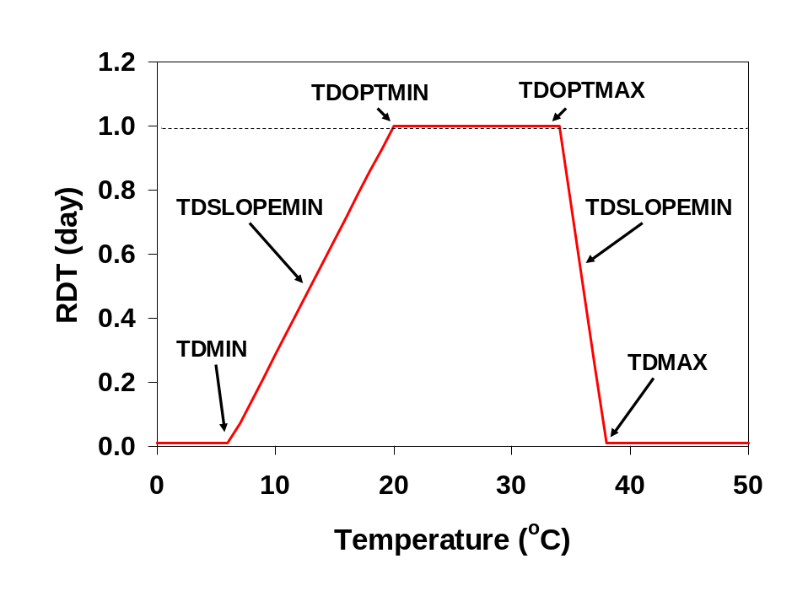
Fig. 2. Four temperatures used to define the response of relative development time to temperature.

(b) Sink-limited growth functions
Sink-limited growth functions describe the potential for leaf area growth as a function of development time (DT). CCROP uses a two-phase approach for this. The first phase is a non-linear phase which is described with a logistics function and the second phase is a linear phase (Fig. 3).
The logistics function used to describe the non-linear phase of sink-limited LA growth is defined by a maximum leaf area value (LAMAX) and an inflection point (DTFL) which is the DT when LA is one-half LAMAX. LAMAX itself is a function of substrate volume (Fig. 4). DTFL is plant specific and therefore read in from the plant input file. DTFL also represents the point where the linear growth phase begins. Therefore, in Fig. 3 linear growth supercedes the logistics function once DT=DTFL. The following equations describe these two phases of sink-limited growth.

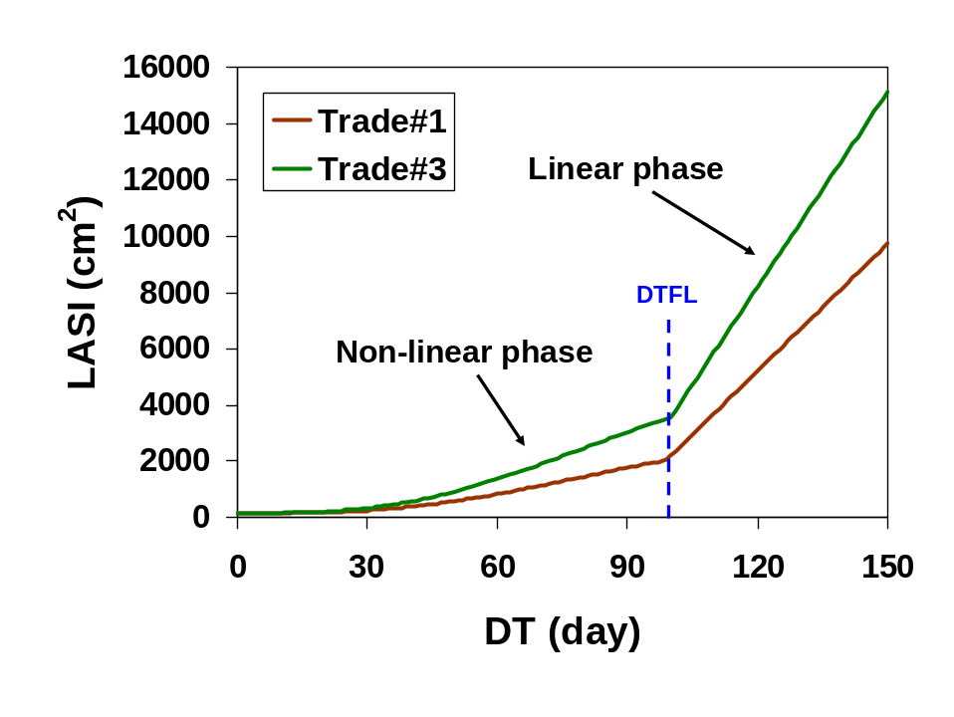
Fig. 3. Relationship between development time (DT) and potential sink-limited leaf area growth (LASI) for sweet viburnum.

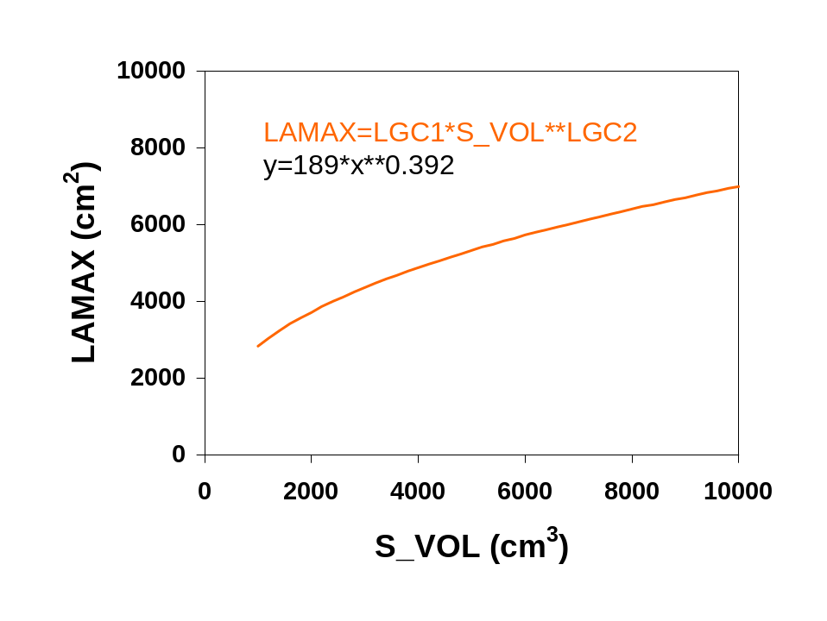
Fig. 4. Leaf area maximum (LAMAX) as a function of substrate volume (S_VOL). LAMAX is used in logistics function for sink-limited leaf area growth.

Non-linear phase – logistics function:
LAMAX=LGC1*S_VOL**LGC2
DTFL=LGC5

IF(DT.lt.DTFL)THEN
LASI=LAMAX-(LAMAX-ILA)/(1+(DT/DTFL)**3)
d_LA=(LASI-LASIY)*min(NSUF,WSUF)
LASIY=LASI
ELSE
d_LA=LGC3*S_VOL**LGC4*RDT*min(NSUF,WSUF)
ENDIF

LAMAX=maximum leaf area for logistics function (cm²)
LGC1, LGC2, LGC5 = plant specific leaf growth coefficients
S_VOL= substrate volume (cm³)
DTFL=inflection point (day)
LASI= leaf area for sink-limited growth (cm²)
ILA=initial leaf area (cm²)
DT=development time (day)
d_LA= daily incremental change in LA
LASIY=yesterday’s LA (cm²)
NSUF,WSUF=nitrogen and water sufficiency factors (0-1)

So, when DT < DTFL, the cumulative potential leaf area for sink-limited growth (LASI) is calculated each day based upon DT. The daily incremental change in leaf area is the difference between cumulative LASI today and yesterday. If nitrogen or water are limiting (NSUF or WSUF <1), then potential growth is further limited by multiply by these factors.

Linear phase:
IF(DT.lt.DTFL)THEN
LASI=LAMAX-(LAMAX-ILA)/(1+(DT/DTFL)**3)
d_LA=(LASI-LASIY)*min(NSUF,WSUF)
LASIY=LASI
ELSE
d_LA=LGC3*S_VOL**LGC4*RDT*min(NSUF,WSUF)
ENDIF

d_LA= daily incremental change in LA
LGC3 and LGC4 are plant specific leaf growth coefficients (cm²)
S_VOL= substrate volume (cm³)
RDT=relative development time or incremental daily change in DT (day)
NSUF, WSUF=nitrogen and water sufficiency factors (0-1)

The linear growth phase supercedes the non-linear phase once DT=DTFL. At this point sink-limited growth rate is constant. The constant rate is based upon plant specific parameters LGC3 and LGC4 and substrate volume (Fig. 5). See Joe about using LAI instead of S_VOL.
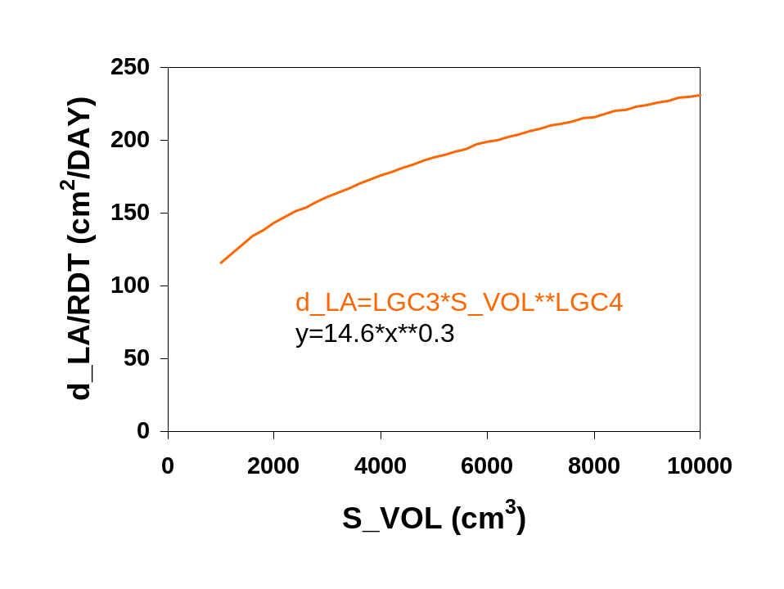
Fig. 5. Growth rate during linear phase of sink-limited growth is a function of S_VOL. For sweet viburnum d_LA/RDT is 151 and 231 for trade #1 (2400 cm²) and trade #3 (10000 cm²) containers.

(c) Conversion of sink-limited leaf area growth to equivalent sink-limited biomass growth
Once d_LA is determined, a calculation is needed to convert leaf area growth to equivalent biomass growth. By converting leaf area to equivalent biomass, then sink versus source relationships can be compared directly. Depending upon LAI, two separate conversions are used (Fig. 6):

IF(LAI.lt.2.5)THEN
d_PWSI=LGC7*d_LA
ELSE
d_PWSI=(LGC7+(LAI-2.5)*LGC8)*d_LA
ENDIF

LAI=leaf area index
d_PWSI=sink-limited biomass growth (g)
LGC7, LGC8=plant specific leaf growth coefficients
d_LA=sink-limited leaf area growth (cm²)
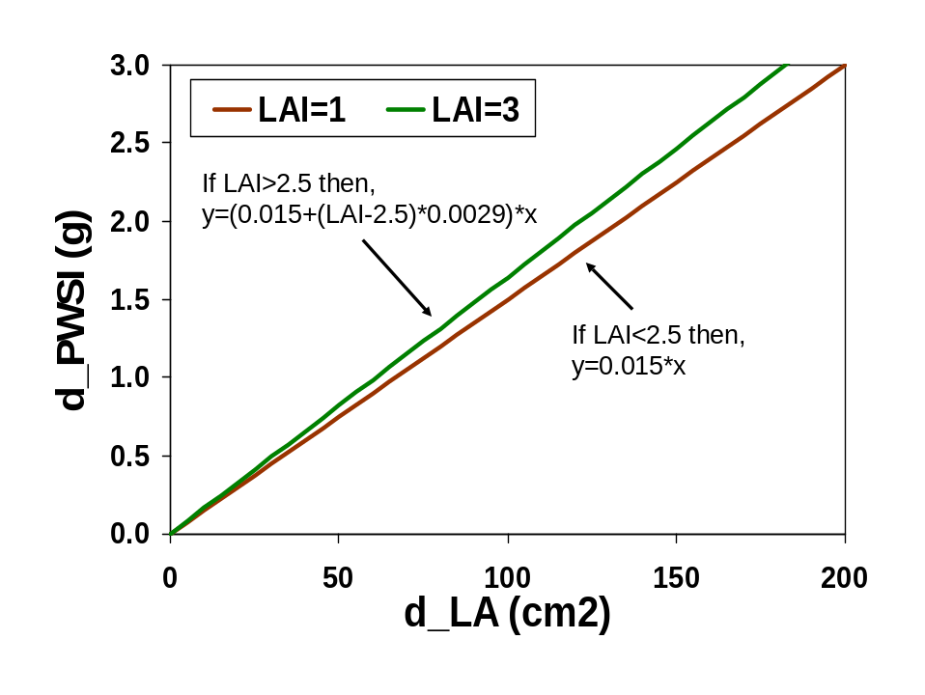
Fig. 5. Conversion of sink-limited leaf area growth (d_LA) to equivalent sink-limited biomass growth (d_PWSI) of whole plant.

(d) Source-limited growth functions
Source-limited growth functions describe the photosynthetic capacity of the plant to produce the biomass necessary for growth. Radiation and temperature are the weather factors that affect source-limited growth functions. Plant-specific factors include temperature sensitivity, light extinction coefficient, and radiation use efficiency.
Temperature effect on photosynthesis is simulated with the following function (Fig.7):

TEMFACSO=PHOTOTEMP1-PHOTOTEMP2*(TBIAS-PHOTOTEMP3)**2 TEMFACSO=MIN(TEMFACSO,1.0)
TEMFACSO=MAX(TEMFACSO,0.0)

TEMFACSO=temperature factor for source-limited growth
PHOTOTEMP1,2,3=plant specific coefficients
TBIAS=biased temperature mean (ºC)(see***)

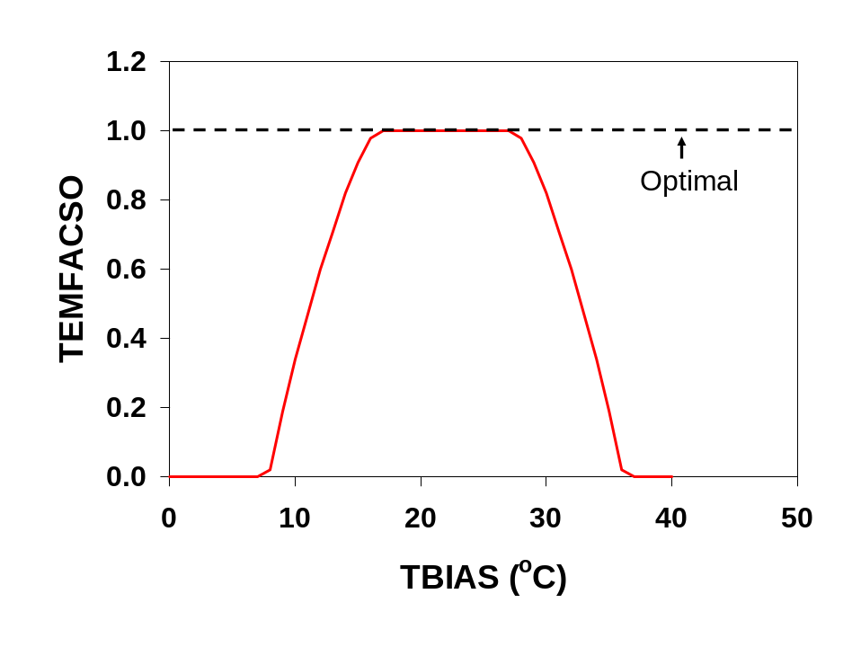

Fig. 7. Temperature factor for source-limited growth function. Temperature bias (TBIAS) is the average of daily minimum temperature and daily maximum temperature biased for solar radiation heating effect on exposed containers.

Source-limited growth rate is described by the following equation:

d_PWSO=RUE*PARB*TEMFACSO*(1-exp(-CINT*LAI))*min(WSUF,NSUF)*0.0001*PTA

d_PWSO=daily incremental change in growth (g)
RUE=plant specific radiation use efficiency (g/MJ)
PARB=biased photosynthetically active radiation (MJ/m²)(see **)
TEMFACSO=temperature factor (0-1)
CINT=light extinction coefficient is a measure of the canopy’s capacity for capturing light and is related to canopy architecture, leaf size, and leaf inclination
LAI=leaf area index
PTA=total area allotted to each container (cm²)
NSUF, WSUF=nitrogen and water sufficiency factors (0-1)

Source-limited growth (d_PWSO) is largely a function of solar radiation (PARB) and LAI (Fig. 8). As LAI approaches 3 to 4, essentially all light is captured and d_PWSO reaches a maximum.

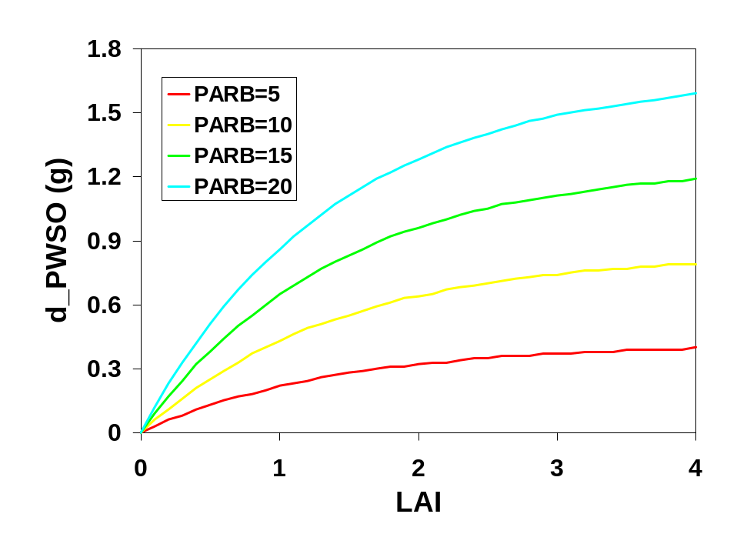
Fig. 8. Effect of LAI on source-limited growth (d_PWSO) at four biased photosynthetically active radiation (PARB) levels.

(e) Actual growth – source versus sink

Now that potential sink and source-limited growth have been calculated, whichever is smallest will determine how much growth will take place any given day.

IF(d_PWSI.ge.d_PWSO) THEN
d_TW=d_PWSO*(1-RTPF)
d_RW=d_PWSO*RTPF
ELSE
d_TW=d_PWSI*(1-RTPF)
d_RW=d_PWSI*RTPF+0.4*(d_PWSO-d_TW)
ENDIF

d_PWSI=potential sink-limited growth (g)
d_PWSO=potential source-limited growth (g)
d_TW=incremental shoot growth (g)
d_RW=incremental root growth (g)
RTPF=root partitioning factor (g root/g plant)

In the first case where source is limiting, d_PWSO is simply partitioned into shoot and root tissue according to RTPF. In the second case where potential sink growth is limiting, a fraction (0.4) of the extra potential source growth is added to the roots.
Once daily incremental growth is determined, cumulative growth is updated:

TW=TW+d_TW
RW=RW+d_RW

TW=shoot biomass (g)
RW=root biomass (g)
d_TW=incremental shoot growth (g)
d_RW=incremental root growth (g)

2. Nitrogen demand, supply and uptake
In CCROP, actual plant uptake of nitrogen (N) depends on whether the supply of N from the substrate is limiting or the N demand of the plant is limiting. The following discussion describes how CCROP simulates these processes and how negative feedback algorithms can reduce growth under N deficiency conditions.

(a) Plant N demand:
Plant N demand is the product of biomass growth (described above) and optimal N concentration. Optimal N concentration is a function DT and plant specific N concentration parameters (Fig. 9):

SLOPEN1=(TW_Noptmax-TW_Noptmin)/DT_Nmin
SLOPEN2=(TW_Noptmax-TW_Noptmin)/(DT_Nmax-DT_Nmin)**2

IF(DT.LE.DT_Nmin) THEN
TW_Nopt=TW_Noptmin+slopeN1*DT
ELSE
TW_Nopt=TW_Noptmin+slopeN2*(DT-DT_Nmax)**2
ENDIF

RW_Nopt=TW_Nopt-RW_Noptdiff

SLOPEN1=rate of change in optimal shoot N conc when DT<DT_Nmin
SLOPEN2=rate of change in optimal shoot N conc when DT=>DT_Nmin
TW_Noptmax=maximum optimal N conc in shoots (g N/g shoot)
TW_Noptmin=minimum optimal N conc in shoots (g N/g shoot)
DT_Nmin=DT when optimal N conc in shoots is at a maximum (day)
DT_Nmax=DT defining SLOPEN2
DT_Noptdiff=difference between TW_Nopt and RW_Nopt

Optimal tissue N concentration increases during early stages of growth as new leaf growth occurs then declines as the proportion of woody tissue to leaf tissue increases with continued biomass growth. Optimum N relationships are plant specific and are determined with N fertilizer experiments where destructive harvests are made periodically during the season and biomass and N conc are determined. Once optimum N concentration values are calculated for shoot and root tissues, then plant demand for N is the product of incremental biomass growth and optimum N concentration plus a fraction (15%) of any deficit carried over from ‘yesterday’:

NDEMAND=0.15*(TW*(TW_Nopt-TW_Nact)+RW*(RW_Nopt-RW_Nact))+
TW_Nopt*d_TW+RW_Nopt*d_RW

NDEMAND=N demand of whole plant (g)
TW=shoot biomass (g)
TW_Nopt=optimum N conc in shoot (g/g)
TW_Nact=actual N conc in shoot (g/g)
RW=root biomass (g)
RW_Nopt=optimum N conc in root (g/g)
RW_Nact=actual N conc in root (g/g)
d_TW=daily incremental change in shoot biomass (g)
d_RW=daily incremental change in root biomass (g)

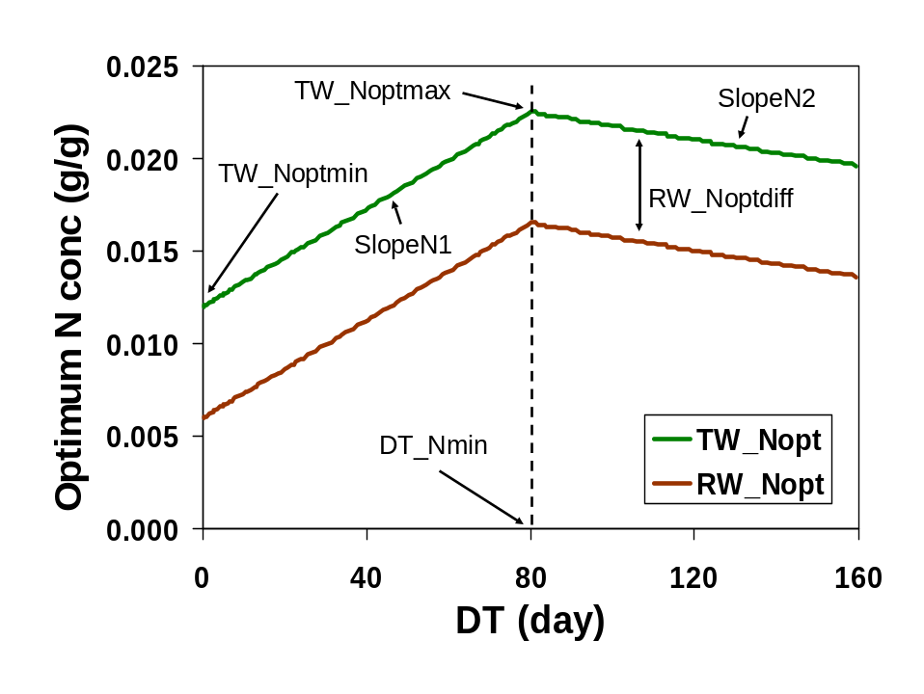
Fig. 9. Optimal N concentration in shoot (TW_Nopt) and root (RW_Nopt) tissues as a function of DT.

(b) N supply:
N supply for plant uptake is a function of available N in substrate, substrate volume, and root biomass (Fig. 10):

SUB_NCONC=SUB_N/SWDUL_cm3*10**6

NSUPPLY=NSUP_MAX1*S_VOL**NSUP_MAX2*(1-exp(-NSUP_RF*RW))*
(1-1/(1.+(SUB_NCONC/NSUP_C1)**NSUP_C2))

SUB_NCONC=N conc in substrate (ug/cm³)
SUB_N=available N in substrate (g)
SWDUL_cm3=water content at drained-upper limit (cm³)
NSUPPLY=N supply for plant uptake (g)
NSUP_MAX1 and NSUP_MAX2=N supply coefficients
NSUP_RF=N supply root factor
RW=root biomass (g)
NSUP_C1 and NSUP_C2=N supply coefficients

N supply coefficients including NSUP_RF are from the plant input file.
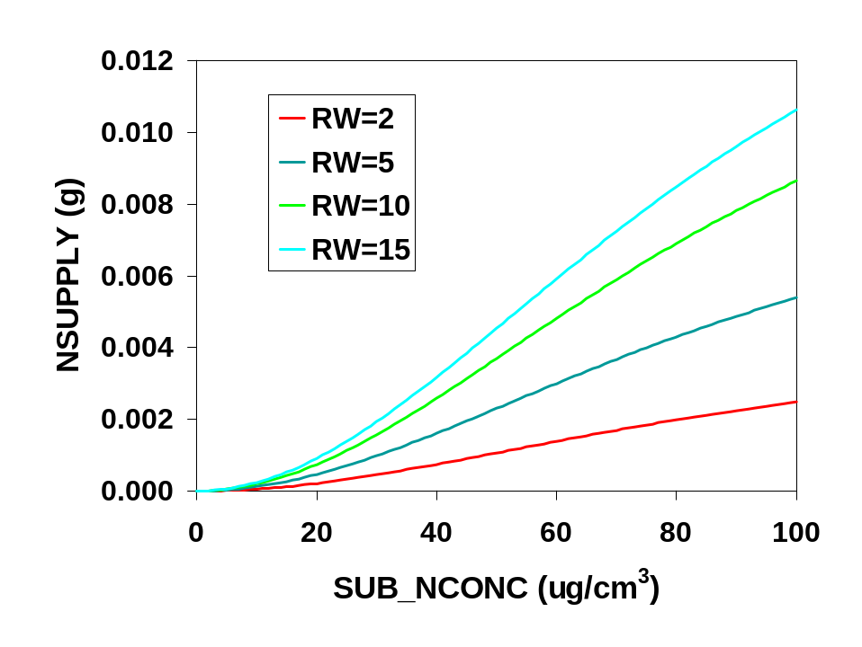
Fig. 10. N supply for plant uptake as a function of substrate N concentration (SUB_NCONC) and root biomass (RW).

(c) N uptake:
Plant N uptake is the lesser of plant N demand and substrate N supply. Nitrogen taken up by the plant then is distributed to shoot and root tissues based upon ratio of optimum N conc in shoot and root tissue:

NUPTAKE=min(NDEMAND,NSUPPLY)

N_PLT=N_PLT+NUPTAKE
RW_Nact=N_PLT/(TW*(TW_Nopt/RW_Nopt)+ RW)
N_ROOT=RW*RW_Nact
N_TOP=N_PLT-N_ROOT
TW_Nact=N_TOP/TW

NUPTAKE=N taken up by plant (g)
NDEMAND=N demand of whole plant (g)
NSUPPLY=substrate N available for plant uptake (g)
NPLT=N content of plant (g)
RW_Nact=root N concentration (g/g)
TW=shoot biomass (g)
TW_Nopt=optimum N conc in shoot (g/g)
RW_Nopt=optimum N conc in root (g/g)
RW=root biomass (g)
N_ROOT=N content of roots (g)
N_TOP=N content of shoots (g)
TW_Nact=shoot N concentration (g/g)

(d) N sufficiency:
N sufficiency in the plant is based upon the deviation of actual shoot N concentration from optimum shoot N concentration (Fig. 11):

TRELN=(TW_Nact-TW_Nmin)/(TW_Nopt-TW_Nmin)

TRELN=relative N sufficiency in shoot (0-1)
TW_Nact=shoot N concentration (g/g)
TW_Nmin=minimum shoot N conc (g/g)
TW_Nopt=optimum shoot N conc (g/g)
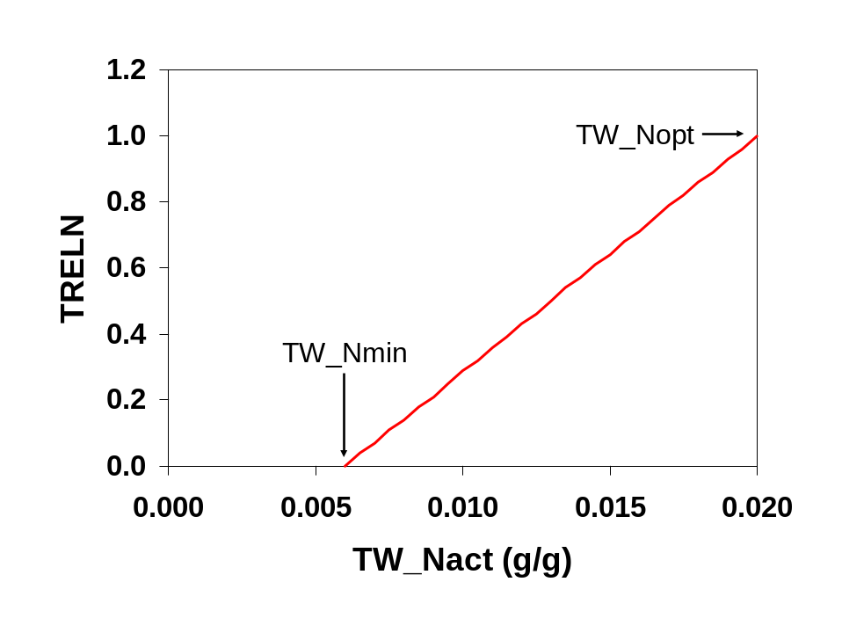
Fig. 11. Relative N sufficiency (TRELN) as a function of shoot N concentration (TW_Nact) when TW_Nmin=0.006 and TW_Nopt=0.02 g/g.

An N sufficiency factor that is used to negatively feedback on plant growth if N concentration in plant tissue reaches a critical level is calculated with the following (Fig. 12):

IF(TRELN.LT.NSUF_TF) THEN
NSUF=NSUF_C1*TRELN**NSUF_C2
ELSE
NSUF=1.
ENDIF

TRELN=relative N sufficiency factor
NSUF=N sufficiency factor (0-1
NSUF_TF=N sufficiency threshold factor
NSUF_C1 and NSUFC2=N sufficiency coefficients

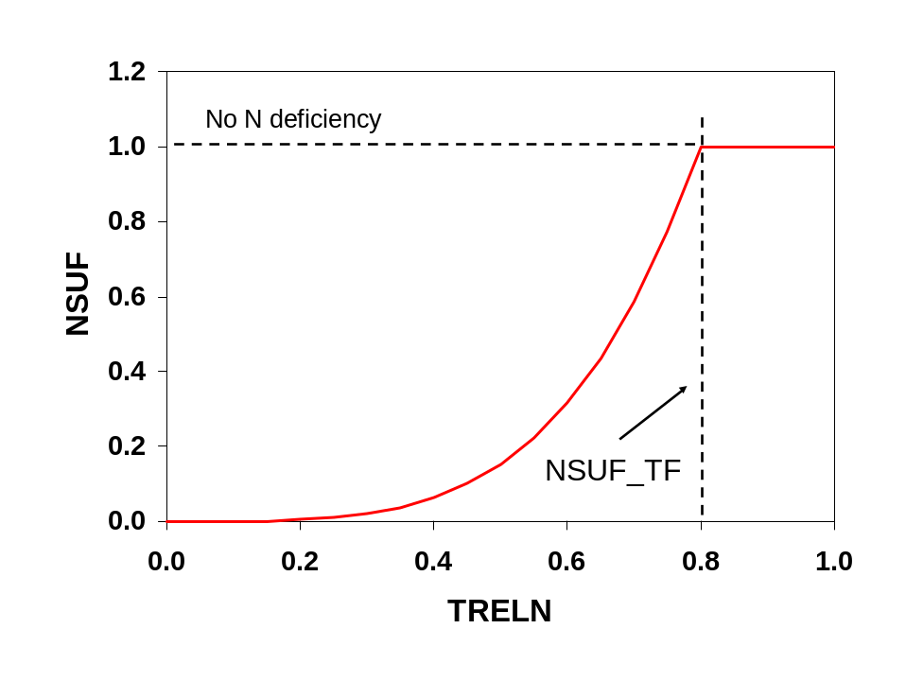
Fig. 12. N sufficiency factor (NSUF) used to reduce plant growth under conditions of N deficiency as a function of relative N sufficiency in shoots (TRELN).

The N sufficiency threshold factor allows shoot N conc to fall below optimum shoot N conc before N deficiency (NSUF<1) is observed. NSUF is subsequently used as a potential modifier of sink and source-limited growth functions.

3. Evaporation and water sufficiency
Evaporation processes for both substrate (evaporation) and plant (transpiration) are discussed in this section. Potential evaporation describes the maximum potential rate of evaporation from plant or substrates. Actual evaporation is less than potential evaporation if water availability in substrate is limiting. Because plant transpiration equations are based total area but plants must obtain water from containers occupying only a fraction of the production area, additional calculations are needed to convert evaporation rates on a per-container basis.

(a) Potential evaporation
Potential evaporation calculations are based upon equations developed for humid climates in which vapor pressure deficit is estimated from temperature (Fig. 13).

LATHEAT=(25.01-TMEAN/42.3) !This is for cm/day units
GAMMA=0.000665*PRESS
DELTA=2503*EXP(17.27*TMEAN/(TMEAN+237.3))/(TMEAN+237.3)**2
RADCOM=DELTA/(DELTA+GAMMA)*SOLAR*0.63/LATHEAT
VPD=0.6108*EXP(17.27*BTMEAN/(BTMEAN+237.3))-0.6108*EXP(17.27*TMIN/
(TMIN+237.3))

AEROCOMP=(GAMMA/(DELTA+GAMMA)*CROPEC*VPD**1.5)/LATHEAT
AEROCOMS=(GAMMA/(DELTA+GAMMA)*6.0*VPD**1.5)/LATHEAT

Potential evaporation is a function of LAI (Fig. 14):

EPO=(RADCOM+AEROCOMP)*(1.-EXP(-0.92*LAI))
ESO=(RADCOM+AEROCOMS)*EXP(-0.6*LAI)

ESO_cm3=ESO*POT_TOPAREA
EPO_cm3=EPO*PTA

LATHEAT=latent heat of evaporation (
TMEAN=average daily temperature (see **)
GAMMA=subcalculation (
PRESS=atmospheric pressure (
DELTA=subcalculation (
RADCOM=radiation component (
SOLAR=solar radiation (MJ)
VPD=vapor pressure deficit (
BTMEAN=biased temperature mean ( (see **)
TMIN=minimum daily temperature (ºC)
AEROCOMP=aerodynamic component for plant evaporation (
AEROCOMS=aerodynamic component for substrate evaporation (
CROPEC=crop evaporation coefficient (
EPO=potential plant evaporation (cm)
ESO=potential substrate evaporation (cm)
LAI=leaf area index (cm² /cm²)
ESO_cm3=potential substrate evaporation (cm³/container)
EPO_cm3=potential plant evaporation (cm³/container)
POT_TOPAREA=top area of container (cm²)
PTA=production area allotted each container (cm²)

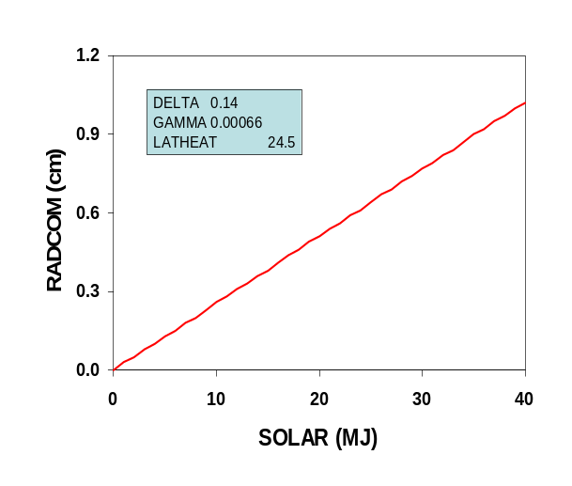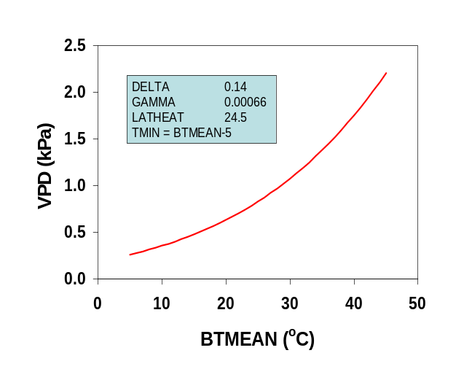
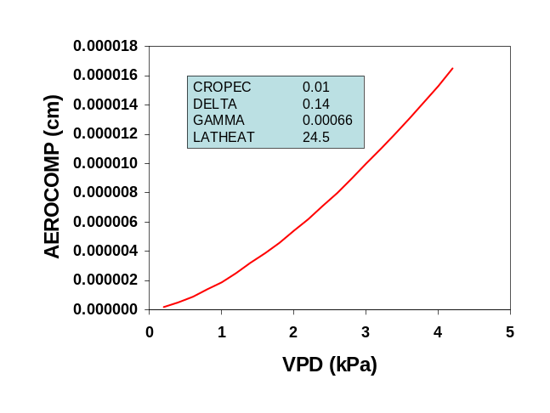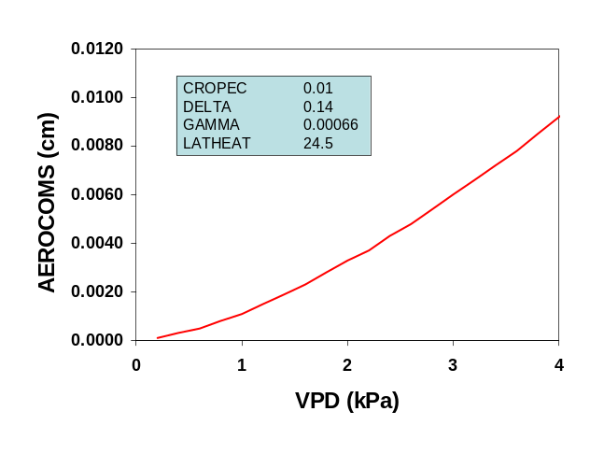
Fig. 13. Functions used in potential evaporation calculations. Specific conditions used to generate the graphs are given in colored box.

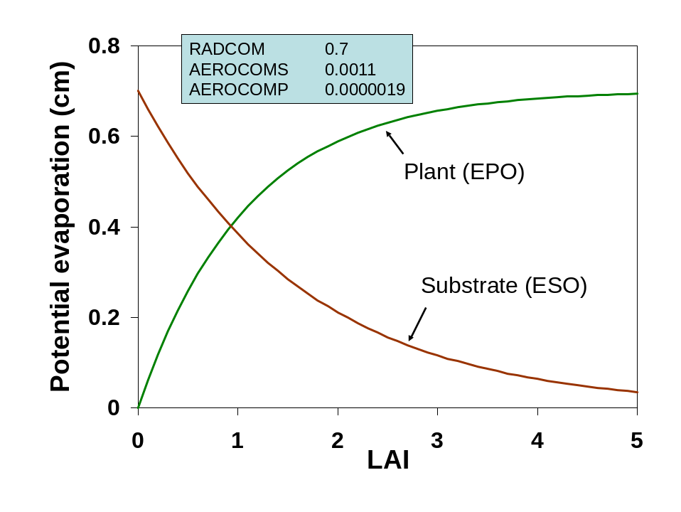
Fig. 14. Potential substrate (ESO) and plant (EPO) evaporation as a function of leaf area index (LAI).
(b) Actual evaporation
Actual substrate and plant evaporation rates are less than potential rates if water is limiting. The following algorithms are used to determine if water is limiting and adjusts evaporation rates accordingly.

Actual substrate evaporation:
Actual substrate evaporation per container (ES_cm3) is based upon substrate water content (SW_cm3) and actual plant evaporation (EP_cm3). If substrate water content is ≥85% of substrate water content at the drained upper limit (container capacity) then ES is allowed to occur at a relatively high rate (Fig. 15). As the substrate water content falls below this threshold water content, ES is limited to a greater extent. In either case, ES also takes into account expected EP.

IF(SW_cm3.gt.0.85*SWDUL_cm3) THEN
ES_cm3=min(ESO_cm3,0.08*(((SW_cm3-0.5*EP_cm3)/S_VOL)-0.02)*S_VOL)
ELSE
ES_cm3=min(ESO_cm3,0.05*(((SW_cm3-0.5*EP_cm3)/S_VOL)-0.02)*S_VOL)
ENDIF

SW_cm3=substrate water content (cm³)
SWDUL_cm3=substrate water content at drained-upper limit (cm³)
ES_cm3=actual substrate evaporation (cm³)
ESO_cm3=potential substrate evaporation (cm³)
EP_cm3=actual plant evaporation (cm³)
S_VOL=substrate volume (cm³)
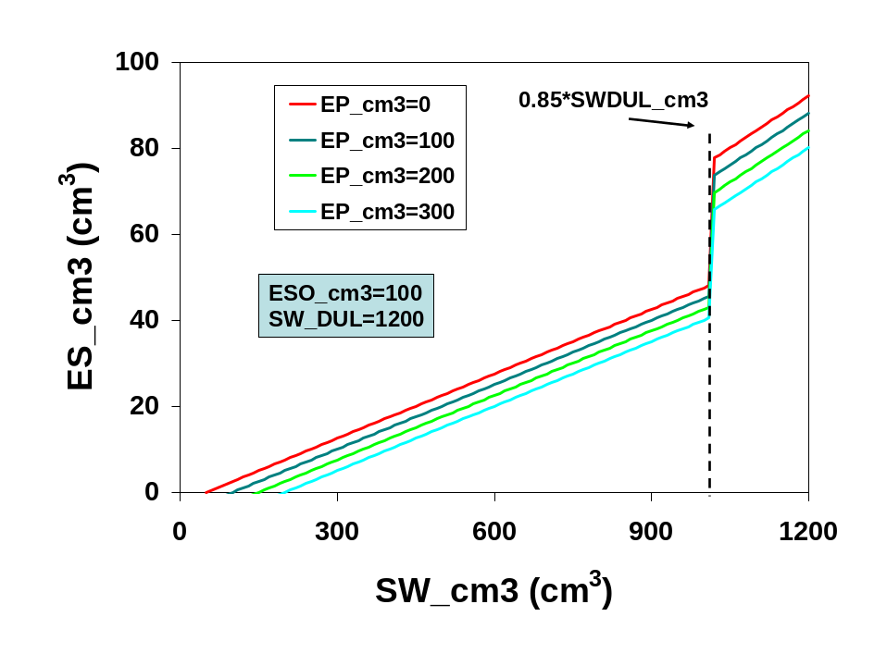
Fig 15. Actual substrate evaporation (ES_cm3) as a function of substrate water content (SW_cm3) and several rates of actual plant evaporation (EP_cm3). Actual substrate evaporation decreases as substrate water content falls below threshold and as plant evaporation increases.
Actual plant evaporation and evapotranspiration:
Actual plant evaporation (EP_cm3) is reduced if available substrate water content (A_SW_cm3) <80% of substrate available water-holding capacity (SWA_cm3). In this case, a substrate water deficit factor (SW_DF) is calculated as the proportion of available water relative to 80% of available water-holding capacity. EPO_cm3 is reduced by this factor to arrive at EP_cm3. Evapotranspiration (ET_cm3) is the sum of actual substrate and plant evaporation. The following equations describe this logic. A graph showing the relationship between water contents at drained upper limit (container capacity), lower limit (wilting point) and available water are given in Fig. 16.

IF(SW_cm3+POT_IRRIG_cm3+POT_RAIN_cm3.lt.0.8*SWA_cm3+SWLL_cm3) THEN
SW_DF=(SW_cm3+POT_IRRIG_cm3+POT_RAIN_cm3)/(0.8*SWA_cm3+SWLL_cm3) ELSE
SW_DF=1
ENDIF

EP_cm3=EPO_cm3*SW_DF
ET_cm3=EP_cm3+ES_cm3

SW_cm3=substrate water content (cm³)
POT_IRRIG_cm3=irrigation added (cm³)
POT_RAIN_cm3=rain added (cm³)
SWA_cm3=substrate available water capacity (cm³)
SWLL_cm3=substrate water content at lower limit (cm³)
SW_DF=substrate water deficit factor (0-1)
EP_cm3=actual plant evaporation (cm³)
EPO_cm3=potential plant evaporation (cm³)
ET_cm3=evapotranspiration (cm³)
ES_cm3=substrate evaporation (cm³)

Another algorithm tests whether there is enough water to meet actual ET. If there is not enough then EP_cm3 is reduced accordingly and a new ET_cm3 is calculated.

IF(SW_cm3+POT_IRRIG_cm3+POT_RAIN_cm3-ET_cm3.lt.SWLL_cm3) THEN
EP_cm3=EP_cm3-(SWLL_cm3-(SW_cm3+POT_IRRIG_cm3+POT_RAIN_cm3-ET_cm3))
ET_cm3=ES_cm3+EP_cm3
ENDIF

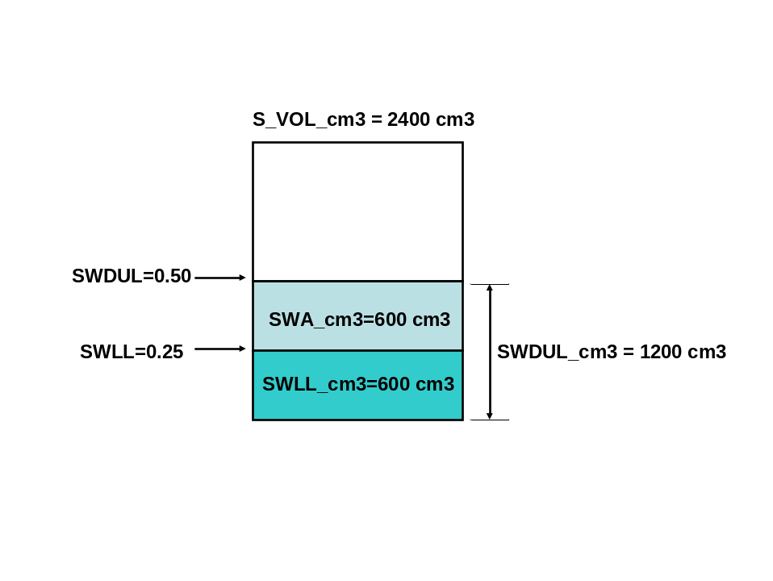
Fig. 16. Relationship between substrate volume (S_VOL_cm3), substrate water content at drained upper limit (SWDUL_cm3), substrate water content at lower limit (SWLL_cm3) and substrate available water holding capacity (SWA_cm3). Arbitrary values are given to show numerical relationship.

(c) Water sufficiency factor:
A water sufficiency factor (WSUF) parameter is calculated by raising SW_DF to the 8th power reflecting greater water sufficiency the closer SW_DF approaches unity (Fig. 17). WSUF is used to reduce growth

WSUF=SW_DF**8

WSUF=water sufficiency factor for reducing growth (0-1)
SW_DF=substrate water deficit factor (0-1)

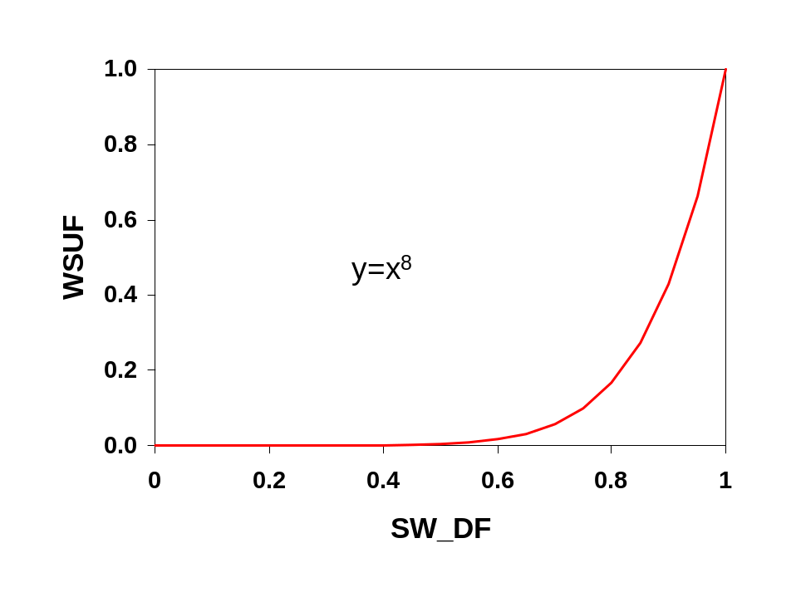
Fig. 17. Water sufficiency factor (WSUF) as a function of substrate water deficit factor (SW_DF) which is the proportion of available water to 80% of the substrate’s available water capacity.

4. N release from controlled-release fertilizer
Controlled-release fertilizers (CRF) are commonly used for container horticulture. Nitrogen release from CRF is simulated with a 2-phase approach defined by the day of maximum release rate and the period of time before (upslope) and after (downslope) the day of maximum release rate (Fig. 18). A CRF with a greater longevity rating will take a longer time to reach maximum release and the maximum release rate will be lower than a CRF with a shorter release rating (Fig. 19). Temperature is the primary environmental factor affecting N release from CRF (Huett and Gogel, 2000). The effect of temperature can be explained by its direct influence on both water vapor pressure and membrane permeability, processes which control the movement of water into and out of the CRF granule (Shaviv et al, 2003). Vapor pressure, which is exponentially related to temperature, is used by CCROP to elicit the temperature effect on N release (Fig. 20). With this in mind, the following equations model N release from a CRF.
The first three equations calculate the temperature effect.

VP=0.611*exp(17.27*TMEAN/(TMEAN+237.3))
CRF_TFAC=0.5225+0.2109*VP
NFERTDAYS=CRF_DAYS*1/CRF_TFAC

VP=vapor pressure (kPa)
TMEAN=average daily temperature (oC)
CRF_TFAC=temperature factor
NFERTDAYS=temperature-modified CRF longevity (day)

This second set of equations computes constants used in N release functions and then computes N release rate.

REL_DAYS=REL_DAYS+1
NPEAKDAYS=0.2947*NFERTDAYS
NPEAKRATE=0.35/NPEAKDAYS
NUPCOEFF=0.175/NPEAKDAYS**2
NDNCOEFF=(0.625-NPEAKRATE*(NFERTDAYS-NPEAKDAYS))/(NFERTDAYS-NPEAKDAYS)**2
NFINALDAYS=NPEAKDAYS-NPEAKRATE/(2*NDNCOEFF)

IF(REL_DAYS.LT.NPEAKDAYS) THEN
RELEASERATE=2*NUPCOEFF*REL_DAYS
ELSE
RELEASERATE=NPEAKRATE+2*NDNCOEFF*(REL_DAYS-NPEAKDAYS)
ENDIF

REL_DAYS=days after application (day)
NPEAKDAYS=days to maximum N release rate (day)
NFERTDAYS=temperature-modified CRF longevity (day)
NPEAKRATE=maximum N release rate (g N/g CRF)
NUPCOEFF=coefficient describing upslope of N release
NDNCOEFF=coefficient describing downslope of N release
NFINALDAYS=days to 100% release
RELEASERATE=fractional release of CRF nitrogen (g N/g CRF)

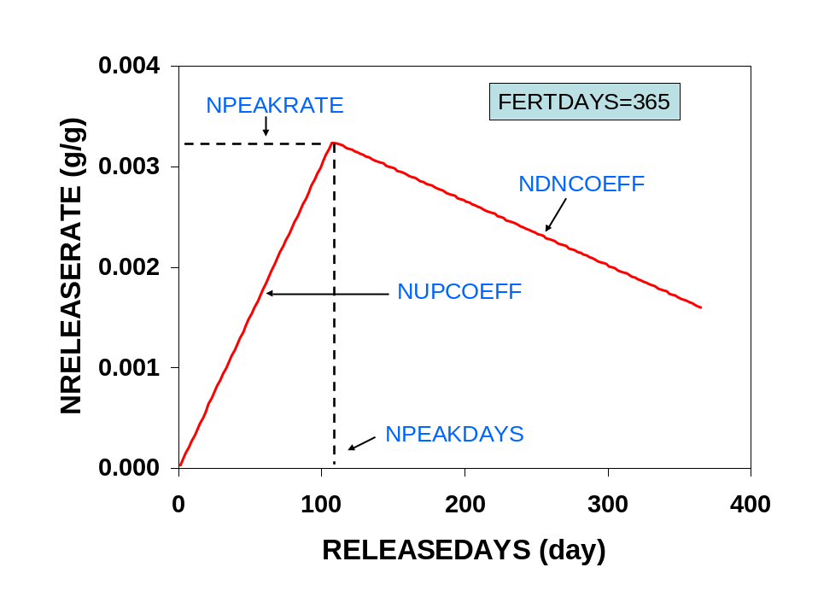

Fig 18. Two-phase approach for modeling N release from controlled-release fertilizer. Fractional N release rate (NRELEASERATE) increases to a maximum rate at NPEAKDAYS and decreases thereafter.

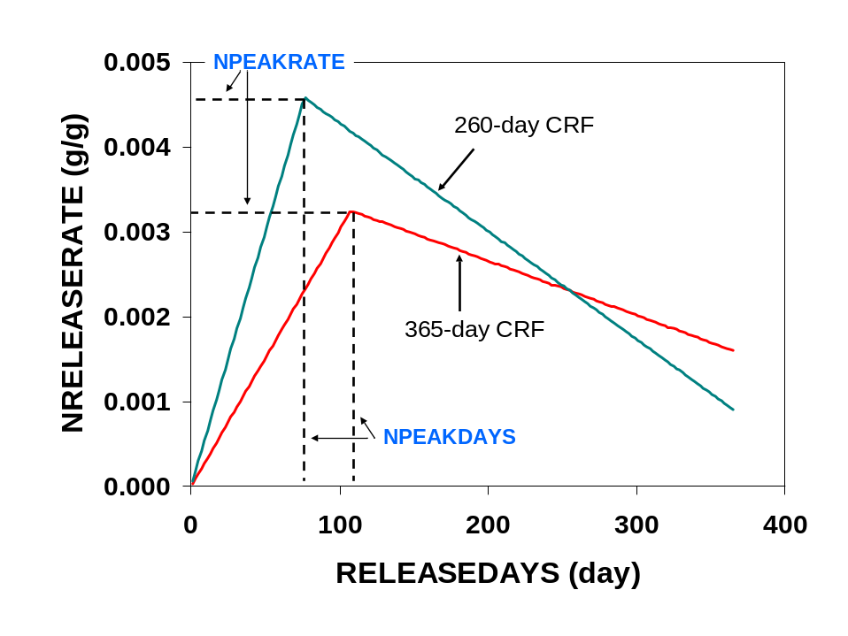

Fig 19. Fractional N release rate (NRELEASERATE) for two CRFs with different longevities. The 365-day CRF takes longer to reach maximum N release and the maximum N release rate is lowe than the 260-day CRF.

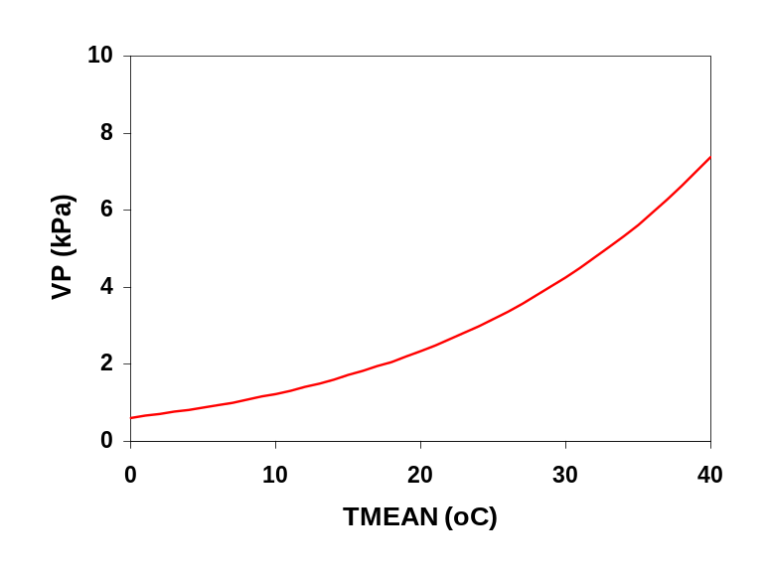
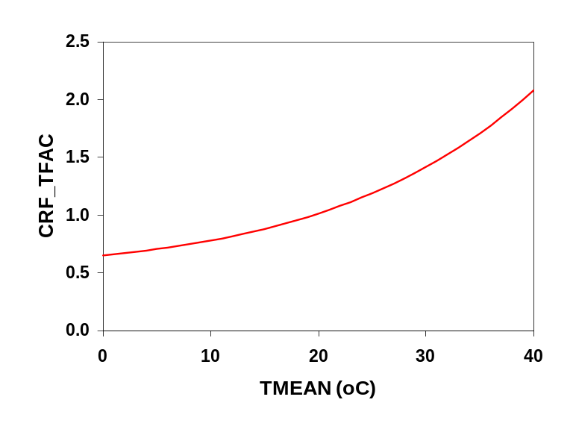
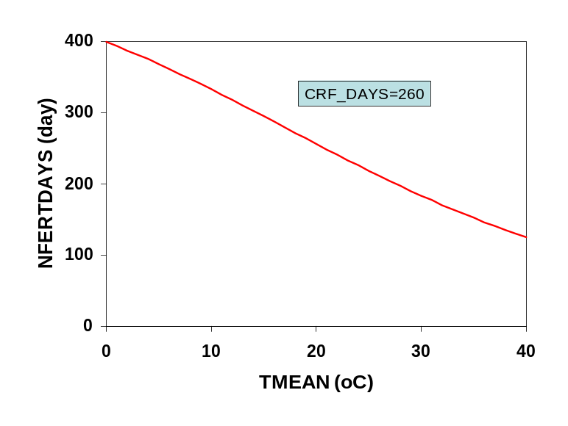

Fig 20. Effect of average daily temperature (TMEAN) on vapor pressure (VP), CRF temperature factor (CRF_TFAC), and ultimately CRF longevity (NFERTDAYS).

5. Supplemental fertilizer
Supplemental fertilizer is fertilizer applied after planting and therefore is in addition to startup fertilizer. Supplemental fertilizer is typically applied when the startup fertilizer becomes inadequate for meeting the plant nutrient requirements. Supplemental fertilizer may be applied as a granular product typically onto the surface of the substrate (topdress fertilizer) or in solution by injecting liquid fertilizer concentrate into the irrigation water (solution fertilizer). While a supplemental topdress application is typically effective for an extended period of time, solution fertilizer is commonly re-applied at regular intervals since it is readily soluble, and leachable, and there is a practical limit to the fertilizer concentration that can be safely applied. Both topdress and solution fertilizer applications can be scheduled by entering a fixed date or by triggering an application when N release from start-up controlled-release fertilizer falls below a threshold percentage of plant N demand. Triggered applications are only allowed after the first 30 days. For solution fertilization, a third option of inputting applications is via an input file.

(a) Supplemental topdress fertilizer
For fixed and triggered topdress applications, the application is initiated by setting release day to 0. The contribution of any readily available fertilizer N is added to the substrate N pool. The equations below just show how the topdress application is scheduled. Once applied, N release from topdress fertilizer (NRELEASE2) uses the same functions as N release from startup CRF (NRELEASE) described previously.

IF(TDF.eq.'FIXED'.and.DAY.eq.TD_DAY)THEN
REL_DAYS2=0
SUB_N=SUB_N+FERT_N2-CRF_N2
ENDIF

IF(TDF.eq.'TRIG') THEN
TD_UPFAC=NDEMAND*TD_TF*.01
IF(NRELEASE.lt.TD_UPFAC.and.DAY.gt.30.and.SUB_N.lt.NDEMAND.and.
REL_DAYS2.eq.-99) THEN
REL_DAYS2=0 !initiate days from topdress application
SUB_N=SUB_N+FERT_N2-CRF_N2 !available N in topdress fertilizer
ENDIF
ENDIF

TDF=topdress fertilizer schedule
DAY=days after planting (day)
TD_DAY=number of days after planting to apply supplemental topdress fertilizer (day)
REL_DAYS2=number of days after supplemental topdress application (day)
SUB_N=substrate N (g)
FERT_N2=supplemental fertilizer N applied (g/container)
CRF_N2=supplemental controlled-release N applied (g/container)
TD_UPFAC=topdress uptake factor (g)
NDEMAND=N plant demand (g)
TD_TF=topdress threshold factor (%)
NRELEASE=N release (g)

(b) Supplemental solution fertilizer
Supplemental solution fertilizer is applied via irrigation water. Supplemental solution fertilizer can be applied on an irregular schedule at variable N concentrations by inputting the application schedule in an input file (SCHED=’FILE’). Otherwise, supplemental fertilizer applications are scheduled to start on a fixed date (or a triggered date), reapplied at a constant time interval and at a constant N concentration. For fixed scheduling, a stop date can be input while for triggered applications the applications at the indicated interval are continued until the crop is finished. The following code shows how these different schedules are implemented.

IF(SF.eq.'FILE')THEN
READ(4,42)SF_NCONC
FORMAT(8X,F6.0)
ENDIF

IF(SF.eq.'TRIG')THEN
SF_START=0
SF_UPFAC=NDEMAND*SF_TF*.01
ENDIF

IF(SF.eq.'TRIG'.and.SF_START.eq.0) THEN
IF(NRELEASE.lt.SF_UPFAC.and.DAY.gt.30.and.SUB_N.lt.NDEMAND) THEN
SF_START=DAY+1
ENDIF
ENDIF

IF(SF.ne.'NONE'.and.DAY.eq.SF_START.and.DAY.lt.SF_END)THEN
IRR_NCONC=SF_NCONC
SF_START=SF_START+SF_INT
ELSEIF(SF.eq.'FILE')THEN
IRR_NCONC=SF_NCONC
ELSE
IRR_NCONC=H2O_NCONC
ENDIF

SF=solution fertilizer schedule
SF_NCONC=solution fertilizer N concentration (ug/cm³)
SF_START=day of solution fertilizer application (day)
SF_UPFAC=threshold N to trigger solution fertilization (g)
NDEMAND=N plant demand (g)
SF_TF=solution fertilizer threshold factor (%)
NRELEASE=N release (g)
DAY=days after planting (day)
SUB_N=substrate N (g)
SF_END=days after planting to end solution fertilizer applications (day)
IRR_NCONC=N concentration of irrigation water (ug/cm³)
SF_INT=interval between solution fertilizer applications (day)
H2O_NCONC=N concentration of irrigation water source (g)

6. Water and N balance
Water and nitrogen dynamics in container production involve balancing inputs and outputs of water and nitrogen (Fig. 21). Inputs of rain and irrigation water must be balanced by outputs of evaporation water loss and water lost through drainage or un-intercepted irrigation and rainfall. Nitrogen inputs from fertilizer or irrigation water must be balanced by outputs of plant N uptake and N lost in un-intercepted irrigation and drainage water. Runoff in CCROP is the sum of un-intercepted irrigation/rain and container drainage.

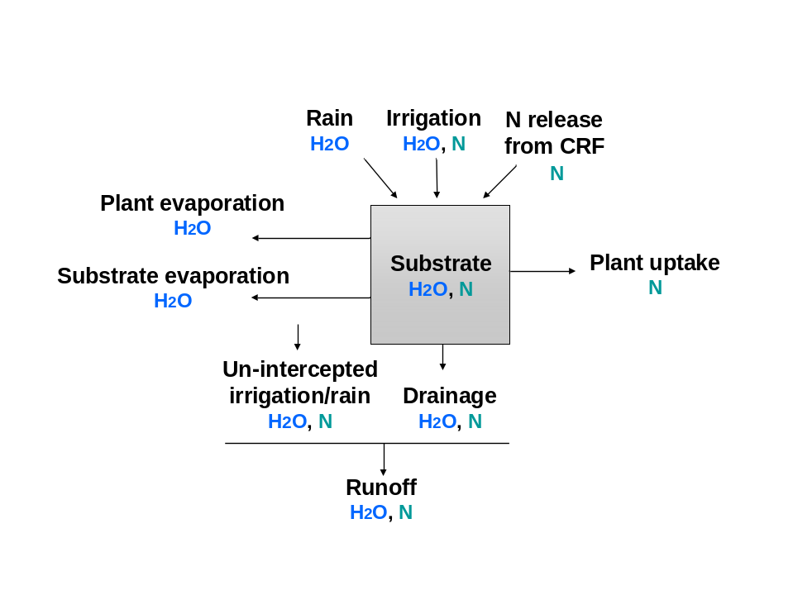

Fig. 21. Simulating water and nitrogen dynamics in container crop production involves balancing inputs and outputs.

(a) Irrigation
CCROP uses three different types of irrigation scheduling to input irrigation water. With an input irrigation file a complete log of daily irrigation inputs can be entered. A fixed irrigation schedule is based upon applying the same amount of irrigation water everyday. With CCROP the fixed amount can be changed up to three times. Also with a fixed schedule, a rain cutoff sensor can be simulated which stops irrigation if ‘yesterday’s’ rain exceeded the fixed amount of irrigation to apply. A third irrigation scheduling option is managed allowable deficit irrigation (MAD) which applies an amount of water that is proportional to the water deficit in the container substrate. In the management input file the user inputs a MAD value which is the percent of available water that must be lost from the container substrate before irrigation is applied. Once available water content falls below the threshold indicated by MAD then irrigation is based upon the amount of water needed to bring the substrate water content up to drained upper limit (container capacity). MAD irrigation scheduling also considers the plant’s capacity for channeling or shedding irrigation water into the container (see **). The following equations indicate how these scheduling options work. For both file and fixed options, irrigation is entered as a depth of water which is subsequently converted to volume per container; for MAD scheduling, the amount of water to apply is based upon a volume so the conversion is not needed.

IF(SCHED.eq.'FILE') THEN
IRRIG_cm3=IRRIG*POT_TOPAREA

ELSEIF(SCHED.eq.'FIXED') THEN
IF(RAINCUT.eq.'YES'.and.Y_RAIN_cm.lt.D_IRR) THEN
IRRIG_cm3=D_IRR*POT_TOPAREA
ELSEIF(RAINCUT.eq.'YES'.and.Y_RAIN_cm.ge.D_IRR) THEN
IRRIG_cm3=0.0
ELSE
IRRIG_cm3=D_IRR*POT_TOPAREA
ENDIF

SW_T_F=1-MAD*0.01 (in water subroutine initialization)

ELSEIF(SCHED.eq.'MAD') THEN
IF(A_SW_cm3.lt.(SWA_cm3)*SW_T_F) THEN
IRRIG_cm3=(SWDUL_cm3-SW_cm3)/IRR_EF
ELSE
IRRIG_cm3=0.0
ENDIF

SCHED=type of schedule to base irrigation on
IRRIG_cm3=irrigation water if no plant effect on capture (cm³)
IRRIG=irrigation water (cm)
POT_TOPAREA=top area of container (cm²)
RAINCUT=cuts off irrigation if yesterday’s rain exceeds today’s fixed irrigation amount
Y_RAIN=yesterday’s irrigation (cm)
D_IRR=irrigation water for fixed irrigation schedule (cm)
SW_T_F=substrate water threshold factor
A_SW_cm3=available substrate water (cm³)
SWA_cm3=available substrate water capacity (cm³)
SWDUL_cm3= substrate water content at drained-upper limit (cm³)

There is also code in CCROP that is designed to work with CCROP-MT so that irrigation can be managed on a real-time basis. With the real-time option, irrigation is based upon MAD scheduling but the user can change the actual amount of irrigation water applied was different than MAD. The way CCROP accomplishes this is to create an input irrigation file based upon MAD output. By doing this the user can amend the input file with CCROP-MT to reflect actual irrigation but the model can still offer a MAD-recommended irrigation rate for ‘today’.

ELSEIF(SCHED.eq.'REALTIME') THEN
IF (YR.eq.IRYR.and.DOY.eq.IRDOY.and.IRSTAT.eq.0) THEN
IRRIG_cm3=IRRIG*POT_TOPAREA
NEXTIR=1
ELSE
IF(A_SW_cm3.lt.(SWA_cm3)*SW_T_F) THEN
IRRIG_cm3=(SWDUL_cm3-SW_cm3)/IRR_EF
ELSE
IRRIG_cm3=0.0
ENDIF
ENDIF
ENDIF

(b) Irrigation enhancement factor
The irrigation enhancement factor (IRR_EF) describes the effect that the plant canopy has on the amounts of overhead irrigation and rainfall that reach the container substrate. The irrigation enhancement factor is the ratio of water that enters the container with a plant to the water than would enter the container without a plant. The potential for the canopy to channel water into the container increases as the size of the plant canopy (leaf area) increases. In CCROP this enhancement effect is modeled using a logistics function relating leaf area and container size to IRR_EF. IRR_EF is limited by the space between containers. The space between containers is described with AREA_RATIO, which is the ratio of area allotted each container to the top area of the container. CCROP assumes that some water will fall between containers even with a dense canopy so irrigation enhancement is limited to 90% of the area ratio. Until additional research is conducted the capacity of the canopy to capture rain is assumed to be the same as its capacity to capture irrigation. The following equations calculate IRR_EF and RAIN_EF.

AREA_RATIO=PTA/POT_TOPAREA (in driver program)

IRR_EF=IF_MAX-(IF_MAX-1)/(1+(LA/(IF_INFL*POT_TOPAREA))**4)

IF(IRR_EF.gt.0.9*AREA_RATIO) THEN
IRR_EF=0.9*AREA_RATIO
ENDIF

RAIN_EF=IRR_EF

AREA_RATIO=ratio of area allotted each container to top area of container
PTA=area allotted each container (cm²)
POT_TOPAREA=top area of container (cm²)
IRR_EF=irrigation enhancement factor
IF_MAX=maximum irrigation enhancement factor
LA=leaf area (cm²)
IF_INFL=factor to calculate inflection point for logistics equation relating LA to IRR_EF RAIN_EF=rain enhancement factor

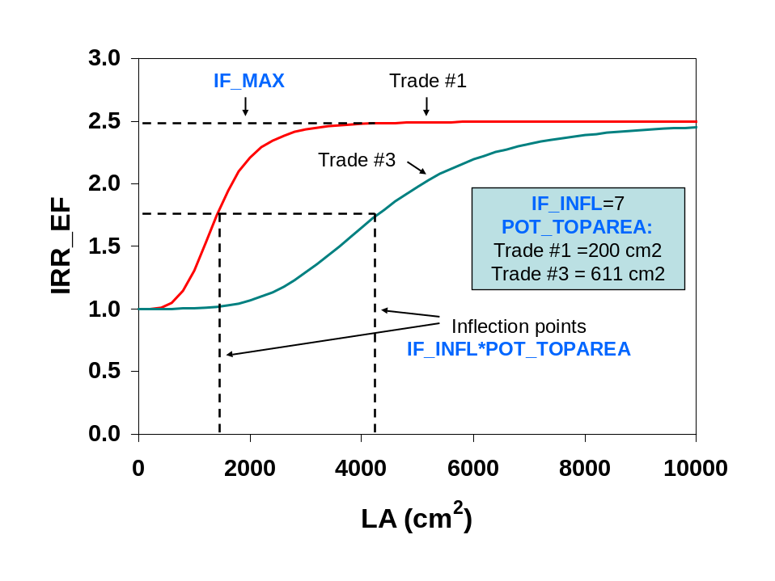
Fig. 22. Irrigation enhancement factor (IRR_EF) describes the capacity of the plant canopy to capture water that would normally fall between containers. The logistics function

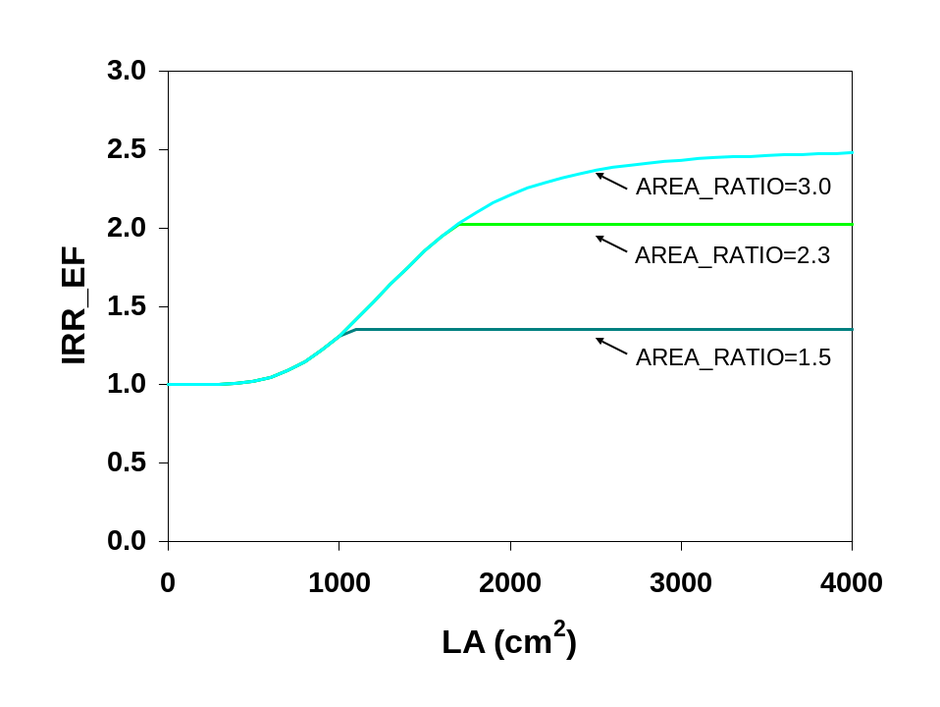

Fig. 23. The ratio of total area allotted the container to the top area of the container (AREA_RATIO) is used to limit IRR_EF since AREA_RATIO describes the relative amount of water that would normally fall outside the container if a plant was not growing in it.

(c) Drainage and runoff
Drainage refers to water that drains out the bottom of containers and occurs when water entering the container exceeds the capacity of the substrate to retain it. Runoff is the sum of drainage and un-intercepted water falling between containers. The following equations calculate drainage, un-intercepted water, and runoff and reset substrate water content accordingly.

POT_IRRIG_cm3=IRRIG_cm3*IRR_EF
TOTAL_IRRIG_cm3=IRRIG_cm3*AREA_RATIO

IF(RAIN_cm.GT.0) THEN
POT_RAIN_cm3=RAIN_cm*POT_TOPAREA*RAIN_EF
TOTAL_RAIN_cm3=RAIN_cm*PTA
ENDIF

SW_cm3=SW_cm3+POT_IRRIG_cm3+POT_RAIN_cm3-ET_cm3

IF(SW_cm3.gt.SWDUL_cm3)THEN
POT_DRAIN_cm3=SW_cm3-SWDUL_cm3
SW_cm3=SWDUL_cm3
ENDIF

THRU_cm3=TOTAL_IRRIG_cm3-POT_IRRIG_cm3+TOTAL_RAIN_cm3-POT_RAIN_cm3
THRU_IRR_cm3=TOTAL_IRRIG_cm3-POT_IRRIG_cm3
RUNOFF_cm3=THRU_cm3+POT_DRAIN_cm3

POT_IRRIG_cm3=irrigation entering container (cm³)
IRRIG_cm3=irrigation water if no plant effect on capture (cm³)
IRR_EF=irrigation enhancement factor
TOTAL_IRRIG_cm3=irrigation in area allotted container (cm³)
AREA_RATIO=ratio of area allotted each container to top area of container
RAIN_cm=rain (cm)
POT_TOPAREA=top area of container (cm²)
RAIN_EF=rain enhancement factor
TOTAL_RAIN_cm3=rain falling in area allotted container (cm³)
PTA=area allotted each container (cm²)
SW_cm3=substrate water content (cm²)
ET_cm3=evapotranspiration (cm³)
SWDUL_cm3=substrate drained-upper limit (cm³)
THRU_cm3=amount of rain and irrigation water falling between containers (cm³)
THRU_IRR_cm3=amount of irrigation falling between containers (cm³)
RUNOFF_cm3=runoff (cm³)

(d) N leaching and runoff N
Nitrogen leaching is the movement of N out of the container substrate via drainage water. While drainage typically accounts for most of the N in runoff, if irrigation water contains appreciable N then N in un-intercepted irrigation can also contribute to runoff N. The amount of available N (SUB_N) that is subject to leaching is dependent upon N release from controlled-release N fertilizer, N applied in irrigation water, N removed by plant uptake or N leached in drainage water (Fig. 21). Equations for the processes affecting SUB_N are given below.

Initial fertilizer N
Substrate N (SUB_N) has an initial value that is dependent upon the initial fertilizer application and the fraction of fertilizer that is controlled-release N.

FERT_N=FERT*PCT_N*0.01
CRF_N=FERT*PCT_CRN*0.01
SUB_N=FERT_N-CRF_N

FERT_N=fertilizer N applied (g)
FERT=fertilizer applied (g)
PCT_N=percent N in fertilizer (%)
CRF_N=controlled-release N applied (g)
PCT_CRN=percent controlled-release N in fertilizer (%)
SUB_N=substrate available N (g)

N additions to substrate N
Inputs to the available pool of N in the substrate include N release from CRF and inputs from irrigation water.

NRELEASE=CRF_N*RELEASERATE
NRELEASE2=CRF_N2*RELEASERATE2

POT_IRR_N=IRR_NCONC*POT_IRRIG_cm3*0.000001

NRELEASE=N release from CRF (g)
CRF_N=controlled-release N applied (g)
NRELEASERATE=rate of N release from CRF (g N/g CRF)(see **)
NRELEASE2=N release from supplemental CRF (g)
CRF_N2=supplemental controlled-release N applied (g)
NRELEASERATE2=rate of N release from supplemental CRF (g N/g CRF)
POT_IRRIG_N=irrigation N added to container (g)
IRR_NCONC=concentration of N in irrigation water
POT_IRRIG_cm3=irrigation into container (g)

Nitrogen leaching and runoff N
N leaching is a product of drainage volume and concentration of N in drainage water. N concentration in drainage water is calculated by dividing substrate N by an amount of water that is proportional to the combined volumes of water held at container capacity and drainage water (Fig. 24). Additions of N in un-intercepted irrigation water are added to drain N to get runoff N. N concentration of runoff water is back calculated knowing runoff volume.

DRAIN_NCONC=SUB_N/(SWDUL_cm3+POT_DRAIN_cm3**1.55) DRAIN_N=DRAIN_NCONC*POT_DRAIN_cm3 THRU_N=THRU_IRR_cm3*IRR_NCONC*0.000001
RUNOFF_N=DRAIN_N+THRU_N

IF(RUNOFF_cm3.gt.0) THEN
R_OFF_NCONC=DRAIN_N/RUNOFF_cm3
ELSE
R_OFF_NCONC=0
ENDIF

DRAIN_NCONC=conc of N in drainage water (ug/cm³)
SUB_N=substrate N (g)
POT_DRAIN_cm3=drainage volume (cm³)
DRAIN_N=drainage N (g)
THRU_N=N in un-intercepted irrigation water (g)
THRU_IRR_cm3=un-intercepted irrigation water falling between containers (cm³)
IRR_NCONC=N conc of irrigation water
RUNOFF_cm3=runoff volume (cm³)
RUNOFFN=runoff N (g)
R_OFF_NCONC=conc of N in runoff water (ug/cm³)

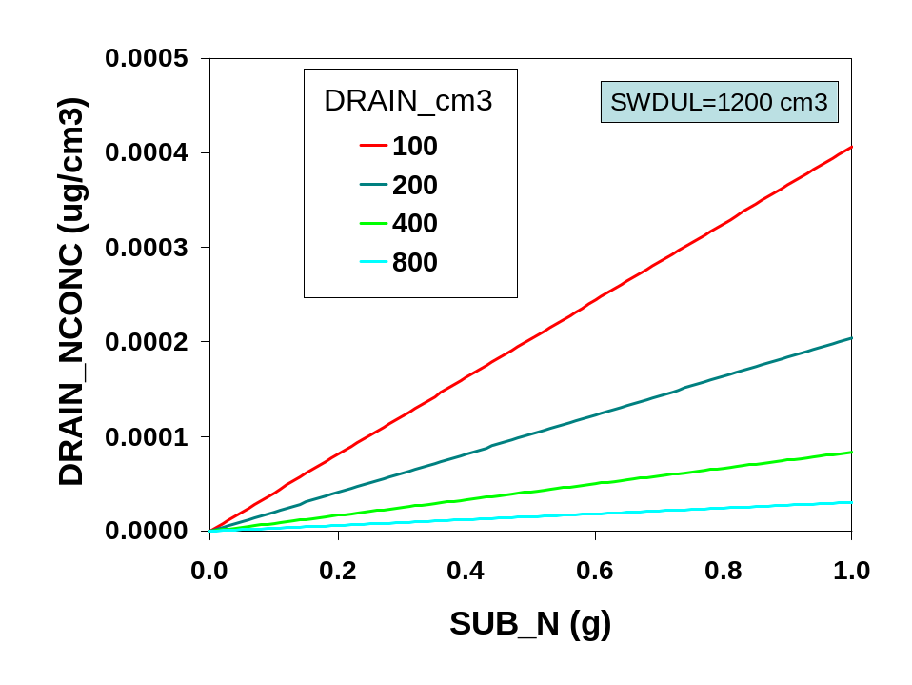

Fig. 24. Nitrogen concentration of drainage water (DRAIN_NCONC) is a function of substrate N (SUB_N) and drainage volume (DRAIN_cm3).

(e) Substrate N balance
N balance is calculated as an integration equation in the driver program.

SUB_N=SUB_N-DRAIN_N+NRELEASE+NRELEASE2-NUPTAKE+POT_IRR_N

SUB_N=substrate N (g)
DRAIN_N=drainage N (g)
NRELEASE=N release from CRF (g)
NRELEASE2=N release from supplemental CRF (g)
NUPTAKE=N taken up by plant (g)
POT_IRRIG_N=irrigation N added to container (g)

7. Pruning and plant size
(a) Pruning
Pruning is the removal of a portion of the shoot in order to promote branching and improve plant uniformity and quality. Removal of biomass and associated leaf area is dependent upon the severity of the pruning. Research has shown that the proportion of leaf area to shoot biomass is greater near the top of the canopy than at the bottom of the canopy where woody stem growth is greater. CCROP assumes that pruning will remove primarily the outermost shoot growth so that terminal buds are removed without excessive loss of shoot biomass. Pruning is scheduled either by inputting a fixed schedule or by selecting a stage of development to trigger a pruning event. If a fixed pruning schedule is selected then the user must input the number of days after planting to prune along with the height and width of the plant after pruning (see management input file). If a triggered pruning is scheduled then the user inputs the development time (DT) to prune and the desired reduction in height from the pruning. Whether fixed or triggered, plant specific factors relating pruning height reduction to biomass and leaf area reduction are used to adjust shoot biomass and leaf area when pruned. N content of shoots is also adjusted to account for N lost in prunings. A delay in growth after pruning is simulated by initiating a 14 development day period during which the prune delay effect (PR_DELAY) decreases rapidly as the 14-day period ends (Fig. 25).

PR_DELAY=2.0 !initialize high so that no delay until prune

IF(PRUNE.eq.'FIXED'.and.DAY.eq.PR_DAY1)THEN
DT_PR=DT
PR_DELAY=0.
PRHT_RED=(HT-PR_HT1)/HT
HT=PR_HT1 !new HT
WIDTH=PR_W1 !new WIDTH
PRUNE_TW=TW*PRHT_RED*PRTWFAC !dwt of prunings
PRUNE_N=PRUNE_TW*1.2*TW_Nact !N content of prunings
TW=TW*(1-PRHT_RED*PRTWFAC) !new TW
LA=LA*(1-PRHT_RED*PRLAFAC) !new LA
N_TOP=N_TOP-PRUNE_N !N in tops after pruning
N_PLT=N_PLT-PRUNE_N !N in whole plant after pruning
ENDIF

IF(PR_DELAY.lt.1.2)THEN
PR_DELAY=0.000364*(DT-DT_PR)**3 !based upon 14 day delay
d_LA=min(d_LA*PR_DELAY,1.) Ask Joe
ENDIF

PR_DELAY=factor (0-1) to reduce leaf area growth after pruning
PR_DAY1=number of days after planting to prune (day)
DT_PR=prune DT used as starting point for 14-day prune delay period
PRHT_RED=fractional height reduction due to pruning
HT=height of canopy (cm)
PR_HT1=height after first pruning (cm)
WIDTH=width of canopy (cm)
PR_W1=width of canopy after first pruning (cm)
PRUNE_TW=biomass of prunings (g)
TW=shoot biomass (g)
PRTWFAC=prune shoot biomass factor
PRUNE_N=N content of prunings (g)
TW_Nact=N concentration in shoot (g/g)
PRLAFAC=prune leaf area factor
N_TOP=N content of shoots (g)
N_PLT=N content of whole plant (g)
PR_DELAY=fractional delay (0-1) in leaf area growth due to pruning.
DT=development time (day)
DT_PR=DT to mark the start of the 14-day prune delay period
d_LA=daily incremental change in leaf area

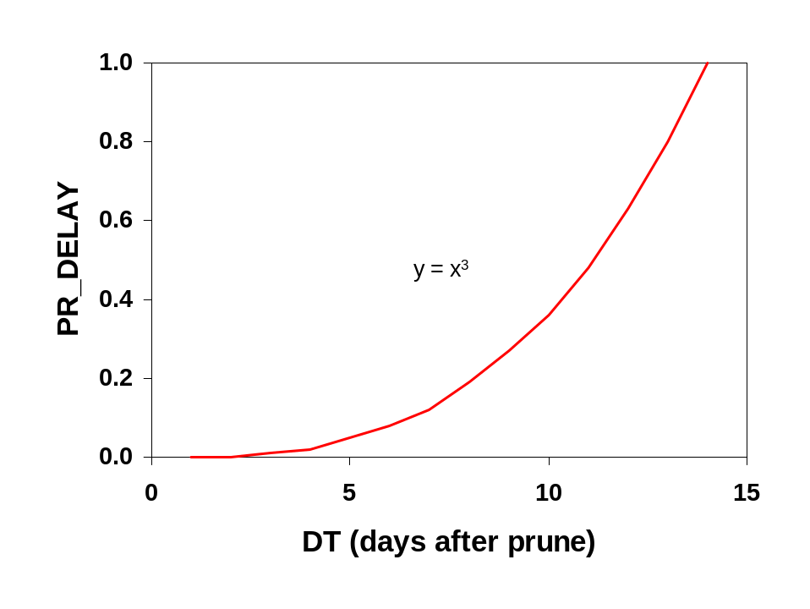
A delay in growth after pruning is simulated by initiating a 14 –day period (DT) during which the prune delay effect (PR_DELAY) decreases rapidly as the 14-day period ends (Fig. 25).

(b) Size relationships
Size refers to the height and width of the plant canopy (shoots). Plant height is the distance from the substrate surface to the uppermost foliage. Plant width is the average of two perpendicular width measurements with the first measurement the widest. Simulating size is important because height and/or width are used to describe the marketable product as it conforms to industry grades and standards.
Plant height and width are estimated with linear functions relating leaf area growth to changes in height and width. The linear responses change as the size of the plant increases. Three critical leaf area values (200, 1025, and 3725 cm²) are used to define these stages.

IF(LA.lt.200)THEN
WIDTH=WIDTH+WDC1*d_LA
HT=HT+HTC1*d_LA
ELSEIF(LA.lt.1025)THEN
WIDTH=WIDTH+WDC2*d_LA
HT=HT+HTC2*d_LA
ELSEIF(LA.lt.3725)THEN
WIDTH=WIDTH+WDC3*d_LA
IF(POTDIAM.gt.18)THEN
HT=HT+HTC32*d_LA
ELSE
HT=HT+HTC31*d_LA
ENDIF
ELSEIF(LA.gt.3725)THEN
WIDTH=WIDTH+WDC4*d_LA
HT=HT+HTC32*d_LA
ENDIF

SIZE=(HT+WIDTH)/2

LA=leaf area (cm²)
WIDTH=average plant width (cm²)
WDC1, WDC2, WDC3, WDC42=linear coefficients
d_LA=daily incremental change in leaf area (cm²)
HT=plant height (cm)
HTC1, HTC2, HTC31, HTC32=linear coefficients
POTDIAM=container diameter (cm)
SIZE=size index (cm)

Plant height and width can be adjusted if values are known to be different. This could be the case when working up experimental data or for calibrating real-time simulations with values measured in the field. Plant height and width adjustments are also made if a pruning event occurs (see p. **) The following code allows for size adjustments.

IF(DAY.eq.CHK_DAY1)THEN
HT=CHK_HT1
WIDTH=CHK_W1
ENDIF

IF(DAY.eq.CHK_DAY2) THEN
HT=CHK_HT2
WIDTH=CHK_W2
ENDIF

IF(DAY.eq.CHK_DAY3) THEN
HT=CHK_HT3
WIDTH=CHK_W3
ENDIF

DAY=days after planting (day)
CHK_DAY1, CHK_DAY2, CHK_DAY3=days after planting to adjust size (day)
HT=plant height (cm)
CHK_HT1, CHK_HT2, CHK_HT3=adjusted height (cm)
WIDTH=average plant width (cm)
CHK_W1, CHK_W2, CHK_W3=adjusted width (cm)

8. Temperature and radiation functions
Several different temperature functions are used for modifying processes simulated by CCROP. The purpose of this section is to describe these functions and to indicate which processes are affected by them.

(a) Average temperature (TMEAN)

TMEAN=max((TMAX*0.5+TMIN*0.5),0.1) evaporation

(b) Temperature mean biased toward daily maximum (TBMEAN)

BTMEAN=TMAX*0.75+TMIN*0.25 photosynthesis, evaporation

(c) Biased photosynthetically active radiation (PARB)

The following series of equations estimate the effect of the sun’s angle and incoming solar radiation on the amount of solar radiation affecting the temperature and potential photosynthetic rate of the plant canopy. The angle of the sun (declination) which depends on location and time of year affects the length of the light path that solar radiation must travel through the atmosphere to reach the plant. As the sun’s angle becomes more obtuse, e.g. during the transition from fall to winter, extraterrestrial solar radiation becomes attenuated to a greater extent.
The heating effect of solar radiation on plant canopy can be estimated in part by estimating the degree of cloudiness. Cloudiness is estimated by calculating what the clear day solar radiation level should be and comparing that to observed solar radiation. This fractional clear day radiation value is then used to estimate the heating effect of solar radiation on temperature affecting photosynthesis.

LAT=LAT*0.01745
SINLAT=SIN(LAT)
COSLAT=COS(LAT)
PRESS=(101.0-0.0107*ALT)/101.0
ESCOR=1-0.016733*COS(0.0172*(DOY-1))
OM=0.017202*(DOY-3.244)
THETA=OM+0.03344*SIN(OM)*(1-0.15*SIN(OM))-1.3526
SINDEC=0.3978*SIN(THETA)
COSDEC=(1-SINDEC**2)**0.5
SINF=SINDEC*SINLAT
COSF=COSDEC*COSLAT
HRANG=ACOS(-SINF/COSF) ETR=37.21/ESCOR**2*(HRANG*SINF+COSF*SIN(HRANG)) H2=SINF+COSF*COS(HRANG/2.)
AIRMASS=PRESS*(-16.886*H2**3+36.137*H2**2-27.462*H2+8.7412) TARCD=0.87-0.0025*TMIN
CDR=ETR*TARCD**AIRMASS
FCDR=min(SOLAR/CDR,1.)
DRF=max(1.33*(FCDR-0.25),0.0)
PARB=min(SOLAR*0.5,CDR*0.5*LGC6)

LAT=latitude (radians)
SINLAT=sine of latitude (radians)
COSLAT=cosine of latitude (radians)
PRESS=atmospheric pressure relative to sea level (kPa)
ALT=altitude(m)
ESCOR=earth sun distance correction (m)
DOY=julian day of year
OM=optical air mass
THETA=optical air mass subcalculation
SINDEC=sine of declination
COSDEC=cosine of declination
SINF=sine subcalculation
COSF=cosine subcalculation
HRANG=hour angle of the sun (radians)
ETR=extraterrestrial solar radiation (MJ/m²)
H2=subcalculation
AIRMASS=optical air mass density
TARCD=clear day transmissivity of air
TMIN=daily minimum temperature (ºC)
CDR=clear day solar radiation (MJ/m²)
FCDR=fraction of clear day solar radiation
SOLAR=solar radiation (MJ/m²)
DRF=direct radiation fraction
PARB=biased photosynthetically active radiation
LGC6=plant specific coefficient

(d) Biased temperature maximum (TMAXB)

BRAD=SOLAR*DRF*exp(-0.7*LAI)*(1-POT_TOPAREA/PTA)
TMAXB=TMAX+KINPUT*BRAD photosynthesis and development

BRAD=biased solar radiation for canopy (MJ/m²)
SOLAR=solar radiation (MJ/m²)
DRF=direct radiation fraction
LAI=leaf area index
POT_TOPAREA=top area of container (cm²)
PTA=total area allotted each container (cm²)
TMAXB=daily maximum temperature biased for radiation heating affect (ºC)
TMAX=daily maximum temperature (ºC)
KINPUT=plant specific coefficient (unitless)

(e) Average temperature biased for radiation heating effect (TBIAS)

TBIAS=(TMIN+TMAXB)/2 photosynthesis

TBIAS=average temperature biased for radiational heating (ºC)
TMIN=daily minimum temperature (ºC)
TMAXB=daily maximum temperature biased for radiation heating affect (ºC)

C. CCROP - Output Files

Output files in CCROP are text (.txt) files which contain either daily or summary output. Daily output files contain a line of output for each day of the simulation while summary output files contain only one line containing the cumulative totals for each yearly simulation run. A discussion of daily and summary output files follows. *=run number. Due to space limitations, headings of output columns are not always the variable name. Variable names are highlighted in blue.

1. Daily output files

(a) General (*_dailyoutput.txt)

YR = year planted (year)
DOY = day of year (julian day of year)
DAY = days after planting (day)
LA = leaf area per plant (cm²)
LAI = leaf area index (cm²/cm²)
TW = plant top dry weight (g)
RW = plant root dry weight (g)
DT = development time (day)
SRad = SOLAR = solar radiation (MJ/m²/day)
TMIN = daily temperature minimum (ºC)
TMAX = daily temperature maximum (ºC)
Ra = RAIN_cm = rainfall in production area (cm)
Ir = IRRIG_cm = irrigation in production area (cm)
EF = IRR_EF = irrigation enhancement factor (unitless)
P_Ra = POT_RAIN_cm = rain entering container (cm)
P_Ir = POT_IRRIG_cm = irrigation entering pot (cm)
Sw = SW_cm = water content in container at start of day (cm)
P_Dr = POT_DRAIN_cm = drainage from container (cm)
Ro = RUNOFF_cm = runoff in production area (cm)
P_Et = POT_ET_cm = evapotranspiration from container (cm)
Ht = HT = plant height (cm)
Et = ET_cm = evapotranspiration from production area (cm)
P_Ar = PTA = production area alloted to each container (cm²)

***Note: Difference between P_Ra and Ra and between P_Ir and Ir is due to EF

(b) Plant (*_plantoutput.txt)

YR = year planted (year)
DOY = day of year (julian day of year0
DAY = days after planting (day)
d_TW = daily incremental change in shoot biomass (g)
d_RW = daily incremental change in root biomass (g)
RW = root biomass (g)
TW = top biomass (g)
N_TOP = N content of tops (g)
N_ROOT = N content of roots (g)
Tact = TW_Nact = actual N concentration in shoot biomass (%)
Ract = RW_Nact = actual N concentration in root biomass (%)
TW_Nopt = optimal N concentration in shoot biomass (%)
RW_Nopt = optimal N concentration in root biomass (%)
NDemand = NDEMAND = N demand of plant (g)
NUptake = NUPTAKE = N taken up by plant (g)
NSupply = NSUPPLY = substrate N available for plant uptake (g)
NSUF = nitrogen sufficiency factor (0-1)
WSUF = water sufficiency factor (0-1)

(c) N release (*_nreloutput.txt)

YR = year planted
DOY = day of year
DAY = days after planting
TMean = TMEAN = average daily temperature (oC)
VP = vapor pressure (kPa)
TFac = CRF_TFAC = temperature factor for modifying N release from CRF (unitless)
Rate = RELEASERATE = daily fractional release rate for CRF (g/g)
NRel = NRELEASE = N released from CRF (g/container)
CumNRel = CUMNRELEASE = cumulative N released from CRF (g/container)
CRF_N = CRF_N_BAL = CRF N remaining (g/container)
NDemand = NDEMAND = N demand of plant (g)
NFD = NFERTDAYS = actual CRF longevity rating (day)
AvT = AVGTEMP = running average of mean daily temperatures (oC)
AvNFD =AVGNFD = running average of NFD (day)
NRel2 = NRELEASE2 = N release from supplemental CRF application (g)
CRF_N2 = CRF_N_BAL2 = supplemental CRF N remaining (g/container)
AvT2 = AVGTEMP2 = running avg. of mean temp for supplemental CRF application
NFD2 = AVGNFD2 = NFD for supplemental CRF application
SUB_N = SUB_N = available N in substrate (g/container)
RD2 = REL_DAYS2 = no. of days after applying supplemental CRF

(d) Runoff (*_leachoutput.txt)

YR = year planted (year)
DOY = day of year (julian day of year)
DAY = days after planting (day)
SubN = SUB_N = available N in substrate (g/container)
DrCm3 = POT_DRAIN_cm3 = volume of drainage (cm³/container)
DrNconc = DRAIN_NCONC = N concentration in drainage water (g/cm³)
DrainN = DRAIN_N = N content of drainage water (g/container)
NRelease = NRELEASE = N released from CRF (g/container)
NUptake = NUPTAKE = N taken up by whole plant (g/plant)
CumDr = DRAIN_CUM_cm3 = cumulative volume of drainage (cm³/container)
CumDrN = CUMDRAIN_N = cumulative N lost in drainage (g/container)
ROcm3 = RUNOFF_cm3 = runoff volume (cm³/container)
RO_Nconc = R_OFF_NCONC = N concentration of runoff (g/cm³)
Ro_N = RUNOFF_N = N in runoff (g/container)
CumRoN = CUMRUNOFF_N = cumulative N in runoff (g/container)
THRU_N = N in irrigation water falling between containers (g/container)
IrN = POT_IRR_N = N supplied in irrigation water (g/container)
CumIrN = POT_IRR_N_CUM = cumulative N supplied in irrigation water (g/container)

Note: for Dr_Nconc and RO_Nconc, g/cm3 * 1,000,000 = mg/L = ppm

(e) Temperature (*_tempoutput.txt)

YR = year finished
DOY = day of year finished
DAY = number of days from plant to finish
TMIN = minimum daily temperature (oC)
TMAX = maximum daily temperature (oC)
TMAXB = maximum dialy temp. biased for solar radiation effect (oC)
SRAD = SOLAR = daily solar radiation (MJ/m2)
FCDR = fractional clear day radiation (unitless)
DRF = direct radiation fraction (unitless)
RDT = relative development time (day)
DT = cumulative development time (day)
TEMF = TEMPFACSO = temperature factor for adjusting photosynthesis
RW = root weight (g)
TW = shoot weight (g)
LA = leaf area (cm2)
LAI = leaf area index (cm2/cm2)

2. Summary output files
Summary files are written on a container basis for efficiency studies or on an area basis for environmental studies. For area basis output, multiply cm by 10 to get equivalent L/m2. For example 20 cm of water is equivalent to 400 L/m².

(a) Container basis (*_summaryoutput.txt)

YR = year finished
DOY = day of year finished
DAY = number of days to finish
Rain = RAIN_CUM_cm3 = cumulative rain (L/container)
Irrig = IRRIG_CUM_cm3 = cumulative irrigation water applied (L/container)
ET = ET_CUM_cm3 = cumulative ET (L/container)
Drain = DRAIN_CUM_cm3 = cumulative drainage volume (L/container)
Runoff = RUNOFF_CUM_cm3 = cumulative runoff volume (L/container)
Nloss = CUMRUNOFF_N = cumulative N loss in runoff (g/container)
NConc = CUMRUNOFF_N*1000000/ RUNOFF_CUM_cm3 = N concentration in runoff (mg/L)
HT = final height (cm)
TW = final shoot biomass (g/plant)
P_Area = AVG_PTA = average area alloted to a container (cm³)

(b) Area basis (*_summaryarea.txt)

YR = year finished (year)
DOY = day of year finished (julian day of year)
DAY = number of days from plant to finish (day)
Rain = RAIN_CUM_cm = cumulative rainfall (cm)
Irr = IRR_CUM_cm = cumulative irrigation water applied (cm)
ET = ET_CUM_cm = cumulative evapotranspiration (cm)
Drain = DRAIN_CUM_cm = cumulative drainage (cm)
Roff = RUNOFF_CUM_cm = cumulative runoff (cm)
NLoad = NLOAD_CUM = cumulative N load (g/m²)

III. CCROP-MT – Management Tools

